

Project Report

Course Code:CSE 303
Course Title:Statistics for Data Science
Section: 08
Summer-2026

Submitted to:

Shartaz Sajid Nahid
Lecturer
Department of CSE
East West University

Submitted By: (Group-7)

Name | ID
Akash Bhowmick | 2022-3-60-308
Kazi Mazharul Islam Mridul | 2023-2-60-098
Munimul Hoque Labib | 2023-2-60-234
Kaisan Faraz Jilan | 2023-3-60-197
Farhan Junaed | 2023-3-60-307
Ratul Hasan Nirjon | 2023-3-60-498

Heart Disease Risk (2026)
Exploratory Data Analysis Report — Group 7

Table of Contents
Introduction 4
Part 1 — Dataset Description 5
1.1 Source and Real-World Problem 5
1.2 Dataset Size 5
1.3 Feature Description Table 5
Part 2 — Central Tendency and Dispersion Analysis 7
2.1 Summary Statistics Table 7
2.2 Interpretation 7
Part 3 — Distribution and Shape 9
3.1 Age 9
3.2 Resting Systolic Blood Pressure 9
3.3 Resting Diastolic Blood Pressure 10
3.4 Total Cholesterol 10
3.5 HDL (Good Cholesterol) 11
3.6 LDL (Bad Cholesterol) 11
3.7 Triglycerides 12
3.8 Fasting Blood Sugar 12
3.9 HbA1c 13
3.10 BMI 13
3.11 Resting Heart Rate 13
3.12 Max Heart Rate Achieved 14
3.13 ST Depression 15
3.14 Alcohol Units per Week 15
3.15 Exercise Minutes per Week 16
3.16 Sleep Hours 16
3.17 Stress Score 17
3.18 Daily Steps 17
3.19 Diet Quality Score 18
3.20 Summary: Shape and Outliers for Every Numerical Feature 19
Key Observations 19
Part 4 — Categorical Variable Analysis 20
4.1 Sex 20
4.2 Chest Pain Type 20
4.3 Exercise-Induced Angina 21
4.4 Family History 22
4.5 Smoker Status 22
4.6 Wearable Owner 23
4.7 Has Heart Disease (Target Variable) 24
Key Observations 24
Part 5 — Relationships Between Variables 25
5.1 Age vs Total Cholesterol 25
5.2 Age vs Total Cholesterol (by Sex) 26
5.3 HDL vs LDL 26
5.4 Age vs BMI (by Sex) 27
5.5 BMI vs Heart Disease 27
5.6 Chest Pain Type vs Heart Disease 28
5.7 Fasting Blood Sugar vs Heart Disease 29
5.8 Family History vs Heart Disease 30
5.9 Resting Blood Pressure vs Heart Disease 30
5.10 Smoking Status & Alcohol vs Heart Disease 31
5.11 Summary: Correlation with Heart Disease 32
5.12 Correlation Matrix (All Features + Target) 33
Key Observations 34
Part 6 — Data Quality Assessment 35
6.1 Missing Values 35
6.2 Duplicate Rows 35
6.3 Unusual / Impossible Values 35
6.4 Discussion 36
Part 7 — Key Insights 37
7.1 The Typical Patient Profile of Heart Disease 37
7.2 The Strongest Single Signals in the Data 37
7.3 Categorical and Lifestyle Insights 37
7.4 Variables Most Useful for Future Predictive Modeling 38
7.5 Final Conclusion 38
Part 8 — Predictive Modeling 39
8.1 Recap of Part 1 and Data Preparation 39
8.2 Train-Test Splitting Methodology 39
8.3 Linear Regression 39
8.4 Logistic Regression 44
8.5 Additional Models (Optional) 47
8.6 Results and Discussion 49
8.7 Conclusions and Key Findings 50

Introduction
Heart disease is one of the leading causes of death worldwide. Doctors often rely on a combination of many factors — blood pressure, cholesterol, age, and lifestyle habits — to judge a patient’s risk. This report explores the Heart Disease Risk 2026 dataset in order to understand which measurements and habits differ between patients with and without heart disease, laying the groundwork for future predictive modeling.
The dataset is published on Kaggle (https://www.kaggle.com/datasets/srisyra02/heart-disease-risk-2026). It is a synthetic dataset that combines clinical measurements, lifestyle habits, and wearable-device activity data for 9,000 patients across 27 variables. The final column, has_heart_disease, is the target variable (1 = has heart disease, 0 = does not); every other column is a feature that can be used to understand or, later, to predict that target.
Property | Value
Number of observations (rows) | 9,000 patients
Number of variables (columns) | 27
Numerical features | 19
Categorical features | 7
Target variable | has_heart_disease (binary: Yes / No)
Source | Kaggle — Heart Disease Risk 2026 (synthetic dataset)

The report is organized into seven parts, following the assignment guidelines: (1) Dataset Description, (2) Central Tendency and Dispersion, (3) Distribution and Shape, (4) Categorical Variable Analysis, (5) Relationships Between Variables, (6) Data Quality Assessment, and (7) Key Insights.

Part 1 — Dataset Description

1.1 Source and Real-World Problem
The dataset is the Heart Disease Risk 2026 dataset, published on Kaggle. It is a synthetic (artificially generated) dataset that combines clinical measurements, lifestyle habits, and activity data to explore heart-disease risk. Doctors typically rely on a combination of many factors — blood pressure, cholesterol, age, and lifestyle — to judge a patient’s risk of heart disease; this dataset allows us to practice exactly that: exploring which measurements and habits differ between patients with and without heart disease.

1.2 Dataset Size
The dataset contains 9,000 observations (patients) and 27 variables/features, comfortably exceeding the assignment’s minimum requirement of 1,000 rows and 10 columns. Of the 27 features, 19 are numerical and 7 are categorical (including the binary target).

1.3 Feature Description Table
The table below describes all 27 features: their Python data type, their meaning, and their statistical classification (numerical continuous/discrete, or categorical nominal/ordinal/binary).
Feature | Data Type | Description | Classification
patient_id | int64 | Unique ID number of each patient | Categorical (nominal) - identifier
age | int64 | Age of the patient in years | Numerical (discrete)
sex | str | Biological sex of the patient (Male / Female) | Categorical (binary)
resting_bp_systolic | int64 | Systolic blood pressure at rest (mm Hg) | Numerical (continuous)
resting_bp_diastolic | int64 | Diastolic blood pressure at rest (mm Hg) | Numerical (continuous)
cholesterol_total | int64 | Total cholesterol level (mg/dL) | Numerical (continuous)
hdl | int64 | HDL - 'good' cholesterol level (mg/dL) | Numerical (continuous)
ldl | int64 | LDL - 'bad' cholesterol level (mg/dL) | Numerical (continuous)
triglycerides | int64 | Triglyceride level (mg/dL) | Numerical (continuous)
fasting_blood_sugar | int64 | Fasting blood sugar level (mg/dL) | Numerical (continuous)
hba1c | float64 | HbA1c - average blood sugar over the last ~3 m... | Numerical (continuous)
bmi | float64 | Body Mass Index (kg/m^2) | Numerical (continuous)
resting_heart_rate | int64 | Resting heart rate (beats per minute) | Numerical (continuous)
max_heart_rate_achieved | int64 | Highest heart rate reached during exercise (bpm) | Numerical (continuous)
chest_pain_type | str | Type of chest pain (Asymptomatic / Non-Anginal... | Categorical (nominal)
exercise_induced_angina | bool | Whether exercise caused chest pain (True/False) | Categorical (binary)
st_depression | float64 | ST-segment depression measured on an ECG (mm) | Numerical (continuous)
family_history | bool | Whether a close family member has heart disease | Categorical (binary)
smoker_status | str | Smoking status (Never / Former / Current) | Categorical (nominal)
alcohol_units_per_week | float64 | Alcohol consumed per week (units) | Numerical (continuous)
exercise_minutes_per_week | int64 | Minutes of exercise per week | Numerical (continuous)
sleep_hours | float64 | Average hours of sleep per night | Numerical (continuous)
stress_score | float64 | Self-reported stress level (0-100) | Numerical (continuous)
wearable_owner | bool | Whether the patient owns a wearable device | Categorical (binary)
daily_steps | int64 | Average daily step count | Numerical (discrete)
diet_quality_score | float64 | Diet quality score (0-100) | Numerical (continuous)
has_heart_disease | int64 | TARGET: 1 = has heart disease, 0 = does not | Categorical (binary) - target

Part 2 — Central Tendency and Dispersion Analysis
For every numerical feature we compute the mean, median, mode, variance, standard deviation, and interquartile range (IQR). If the mean is approximately equal to the median, the distribution is roughly symmetric. If the mean is greater than the median, the distribution is right-skewed (a few unusually large values pull the mean up); if the mean is less than the median, it is left-skewed. patient_id, has_heart_disease and the categorical/boolean columns are excluded here since they are treated separately in Parts 1 and 4.

2.1 Summary Statistics Table
Feature | Mean | Median | Mode | Variance | Std Dev | Q1 | Q3 | IQR
age | 53.98 | 54 | 57 | 169.21 | 13.01 | 45 | 63 | 18
resting_bp_systolic | 127.85 | 128 | 127 | 189.54 | 13.77 | 119 | 137 | 18
resting_bp_diastolic | 80.79 | 81 | 80 | 119.68 | 10.94 | 74 | 88 | 14
cholesterol_total | 188.75 | 189 | 187 | 1041.46 | 32.27 | 167 | 211 | 44
hdl | 55.22 | 55 | 58 | 153.62 | 12.39 | 47 | 64 | 17
ldl | 103.28 | 103 | 99 | 747.6 | 27.34 | 85 | 122 | 37
triglycerides | 152.04 | 151 | 35 | 2646.94 | 51.45 | 117 | 186 | 69
fasting_blood_sugar | 119.47 | 119 | 119 | 518.84 | 22.78 | 104 | 135 | 31
hba1c | 5.79 | 5.8 | 5.8, 5.9 | 0.48 | 0.69 | 5.3 | 6.3 | 1
bmi | 25.26 | 25.3 | 25.8 | 19.11 | 4.37 | 22.3 | 28.2 | 5.9
resting_heart_rate | 80.91 | 81 | 81 | 74.04 | 8.6 | 75 | 87 | 12
max_heart_rate_achieved | 164.84 | 166 | 168 | 453.3 | 21.29 | 150 | 180 | 30
st_depression | 1.01 | 0.7 | 0.2 | 0.92 | 0.96 | 0.4 | 1.4 | 1
alcohol_units_per_week | 5.71 | 4.2 | 1.6 | 25.71 | 5.07 | 2.2 | 7.7 | 5.5
exercise_minutes_per_week | 139.49 | 139 | 0 | 4052.65 | 63.66 | 96 | 183 | 87
sleep_hours | 6.99 | 7 | 7.2 | 1.22 | 1.1 | 6.3 | 7.7 | 1.4
stress_score | 47.97 | 48.1 | 48.7 | 261.23 | 16.16 | 37.1 | 58.9 | 21.8
daily_steps | 6163.66 | 6178 | 500 | 4711877.69 | 2170.69 | 4658 | 7632.75 | 2974.75
diet_quality_score | 59.47 | 59.6 | 52.8 | 209.56 | 14.48 | 49.7 | 69.1 | 19.4

2.2 Interpretation
Age: mean ≈ 54 and median ≈ 54, with IQR 45–63. Mean and median are almost identical, so age is fairly symmetric and covers a realistic adult range (standard deviation ≈ 13 years).
Blood pressure: systolic mean ≈ 128 mmHg and diastolic ≈ 81 mmHg. This sits at the borderline between normal and elevated blood pressure, which is medically meaningful.
Cholesterol (total): mean ≈ 189 mg/dL with a moderate spread (std ≈ 32, IQR 44). Values above 200 mg/dL are considered high, so part of the sample is at risk.
BMI: mean ≈ 25.3. A BMI of 25–30 is classed as overweight, so on average the sample sits just over the healthy-weight boundary.
Signs of right-skewness (mean > median):
- st_depression (mean 1.01 vs median 0.70): most patients have small values but a few have large ones.
- alcohol_units_per_week (mean 5.71 vs median 4.20): the majority drink little, a few drink a lot.
- daily_steps (mean 6,164 vs median 6,178, std ≈ 2,171): the most variable feature (largest IQR ≈ 2,975); its mode is 500, meaning many patients have very low step counts.

Signs of near-symmetry (mean ≈ median):
- stress_score (48.0 vs 48.1) and sleep_hours (7.0 vs 7.0) are almost perfectly balanced.

Interesting modes (spikes at low values):
- exercise_minutes_per_week mode = 0 → many patients record no exercise at all.
- triglycerides mode = 35 → a big group sits at a very low value while the mean stays at 152.

Caution: for continuous variables the mode is rarely informative (each value may appear only once or twice), so it is reported for completeness. Comparing mean vs median only hints at the shape — the shape is confirmed in Part 3 using histograms, density plots, and boxplots, and outliers are counted using the IQR rule. Also, has_heart_disease has 6,273 zeros vs 2,727 ones, so the target is imbalanced, which is important to remember for any future predictive model.
Overall, the sample looks like a realistic middle-aged population with blood pressure, cholesterol, and BMI sitting close to clinical risk boundaries, and several lifestyle features (steps, exercise, alcohol) that are right-skewed.

Part 3 — Distribution and Shape
For each numerical feature we visualize the distribution using a 1×3 layout: a histogram, a density plot (with a smooth red curve), and a boxplot. Two vertical reference lines mark the mean and the median on the histogram/density plot. The shape of each distribution is classified using the skewness coefficient: symmetric when skewness is between −0.5 and +0.5, right-skewed when skewness is greater than +0.5, and left-skewed when skewness is less than −0.5. Outliers are flagged using the IQR rule: a value is an outlier if it falls below Q1 − 1.5×IQR or above Q3 + 1.5×IQR.

3.1 Age
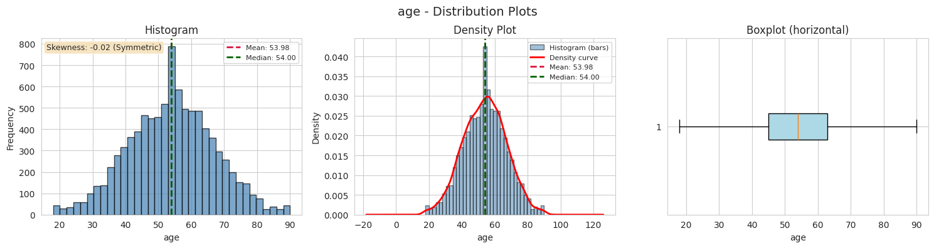
Figure: Histogram, density plot, and boxplot of age.
- Shape: Symmetric (Skewness = -0.022)
- Mean = 53.98 | Median = 54.00 | difference = 0.02 (low -> symmetric)
- IQR = 18.00 (Q1 = 45.00, Q3 = 63.00)
- Outlier bounds: below 18.00 or above 90.00
- Outliers: 0 patients (0.0%)
Age is nicely symmetric (skew ~ -0.02, mean ~ median ~ 54) and the IQR rule finds NO outliers. The sample covers a wide adult age range with no extreme ages.

3.2 Resting Systolic Blood Pressure
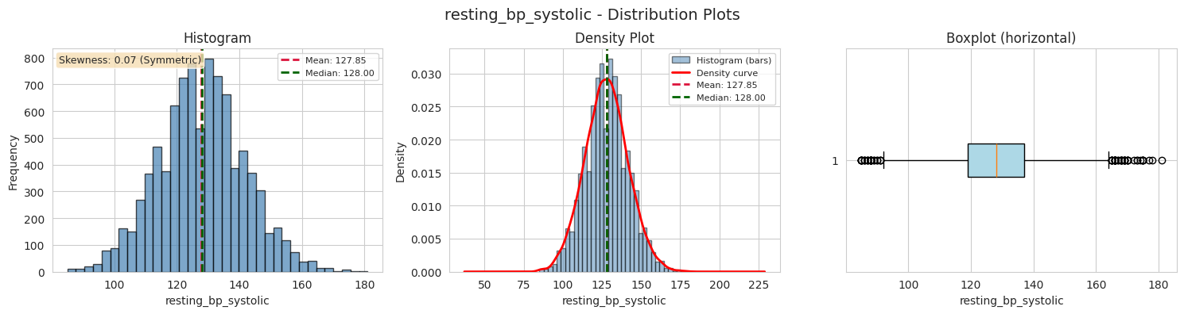
Figure: Histogram, density plot, and boxplot of resting bp systolic.
- Shape: Symmetric (Skewness = 0.068)
- Mean = 127.85 | Median = 128.00 | difference = 0.15 (low -> symmetric)
- IQR = 18.00 (Q1 = 119.00, Q3 = 137.00)
- Outlier bounds: below 92.00 or above 164.00
- Outliers: 66 patients (0.7%)
Nearly symmetric, centred around 128 mm Hg - right at the 'elevated' blood pressure boundary. The 66 high-side outliers (above 164) are patients with clear hypertension; these are clinically real, not data errors.

3.3 Resting Diastolic Blood Pressure
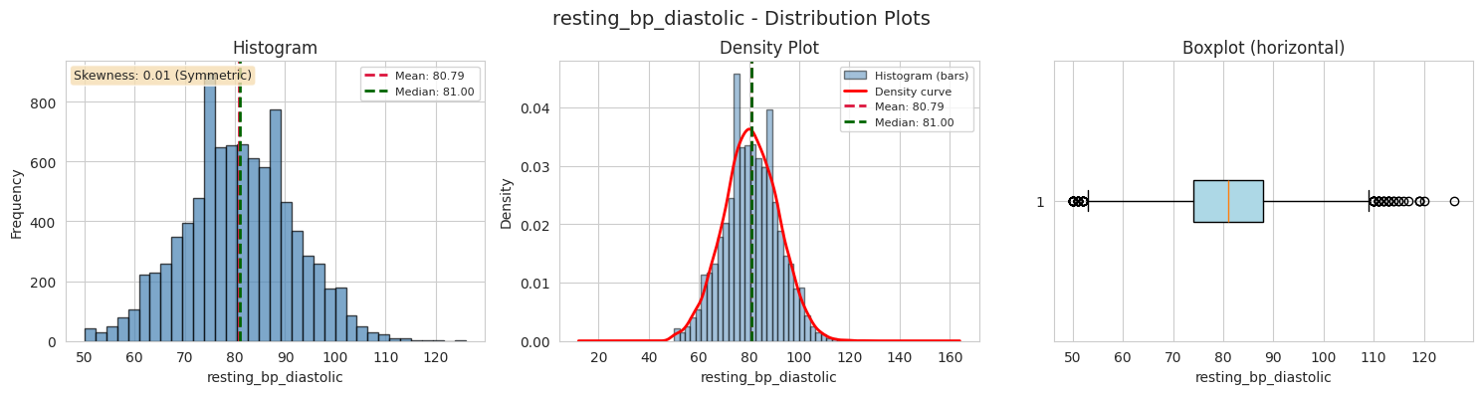
Figure: Histogram, density plot, and boxplot of resting bp diastolic.
- Shape: Symmetric (Skewness = 0.009)
- Mean = 80.79 | Median = 81.00 | difference = 0.21 (low -> symmetric)
- IQR = 14.00 (Q1 = 74.00, Q3 = 88.00)
- Outlier bounds: below 53.00 or above 109.00
- Outliers: 75 patients (0.8%)
Almost perfectly symmetric (skew ~ 0.01) with a tight IQR of 14. The 75 outliers lie mainly on the high side (above 109), pointing to patients with elevated diastolic pressure.

3.4 Total Cholesterol
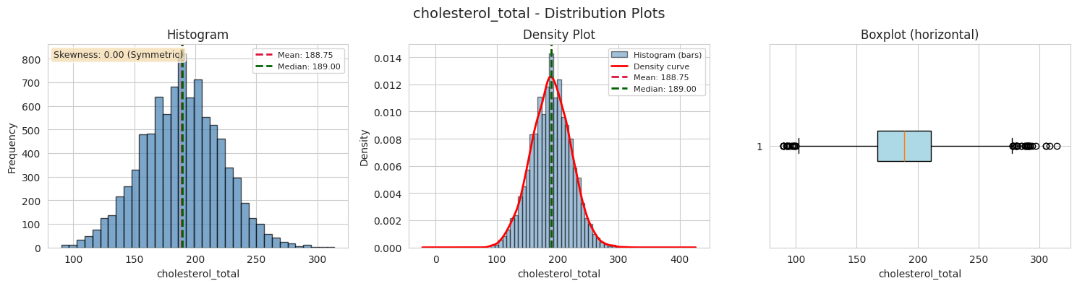
Figure: Histogram, density plot, and boxplot of cholesterol total.
- Shape: Symmetric (Skewness = 0.004)
- Mean = 188.75 | Median = 189.00 | difference = 0.25 (low -> symmetric)
- IQR = 44.00 (Q1 = 167.00, Q3 = 211.00)
- Outlier bounds: below 101.00 or above 277.00
- Outliers: 50 patients (0.6%)
Symmetric around 189 mg/dL - borderline high cholesterol (above 200 is considered high). The 50 high-side outliers (above 277) represent severe hypercholesterolaemia cases.

3.5 HDL (Good Cholesterol)
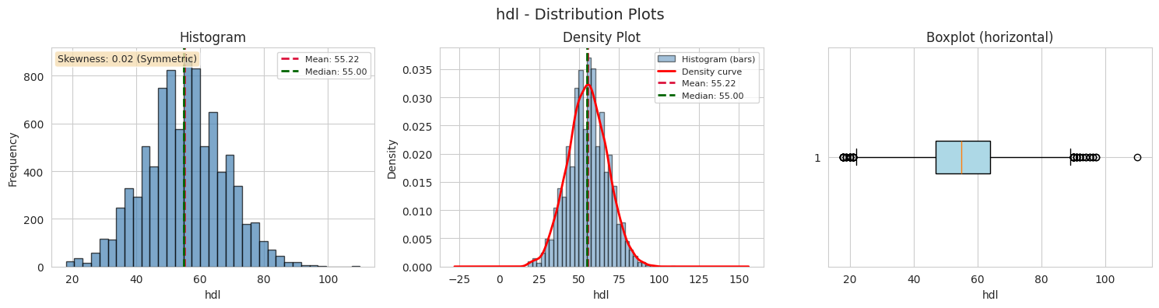
Figure: Histogram, density plot, and boxplot of hdl.
- Shape: Symmetric (Skewness = 0.020)
- Mean = 55.22 | Median = 55.00 | difference = 0.22 (low -> symmetric)
- IQR = 17.00 (Q1 = 47.00, Q3 = 64.00)
- Outlier bounds: below 21.50 or above 89.50
- Outliers: 63 patients (0.7%)
HDL is symmetric around 55 mg/dL. Outliers appear on both sides: very low HDL (below 21.5, poor) and very high HDL (above 89.5, excellent). HDL is the 'good' cholesterol, so higher is better.

3.6 LDL (Bad Cholesterol)
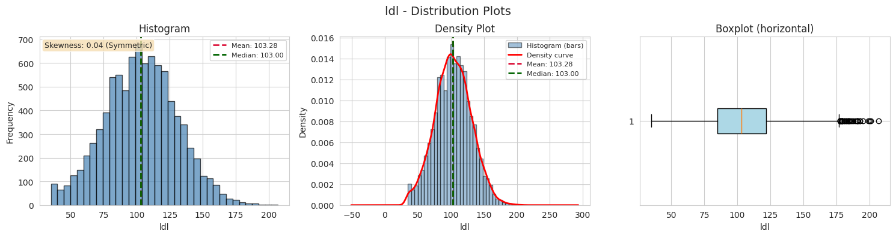
Figure: Histogram, density plot, and boxplot of ldl.
- Shape: Symmetric (Skewness = 0.045)
- Mean = 103.28 | Median = 103.00 | difference = 0.28 (low -> symmetric)
- IQR = 37.00 (Q1 = 85.00, Q3 = 122.00)
- Outlier bounds: below 29.50 or above 177.50
- Outliers: 34 patients (0.4%)
Symmetric around 103 mg/dL. The 34 outliers sit on the high side (above 178) - high LDL ('bad' cholesterol) is a known heart-disease risk factor.

3.7 Triglycerides
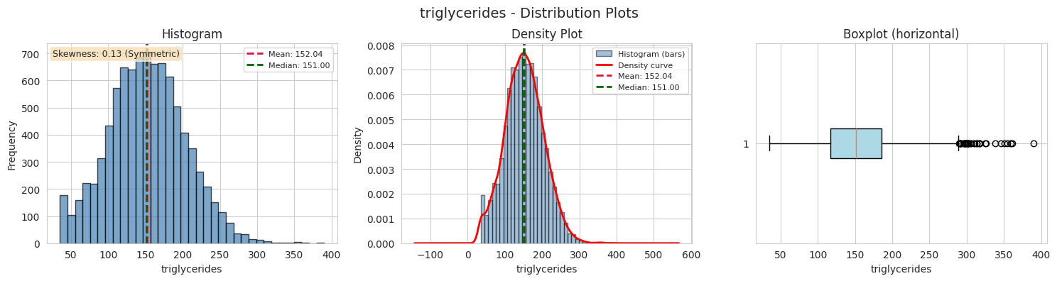
Figure: Histogram, density plot, and boxplot of triglycerides.
- Shape: Symmetric (Skewness = 0.126)
- Mean = 152.04 | Median = 151.00 | difference = 1.04 (low -> symmetric)
- IQR = 69.00 (Q1 = 117.00, Q3 = 186.00)
- Outlier bounds: below 13.50 or above 289.50
- Outliers: 42 patients (0.5%)
Largely symmetric (skew ~ 0.13) but with a big spike at very low values (mode = 35). The 42 high-side outliers (above 290) are patients with very high triglycerides.

3.8 Fasting Blood Sugar
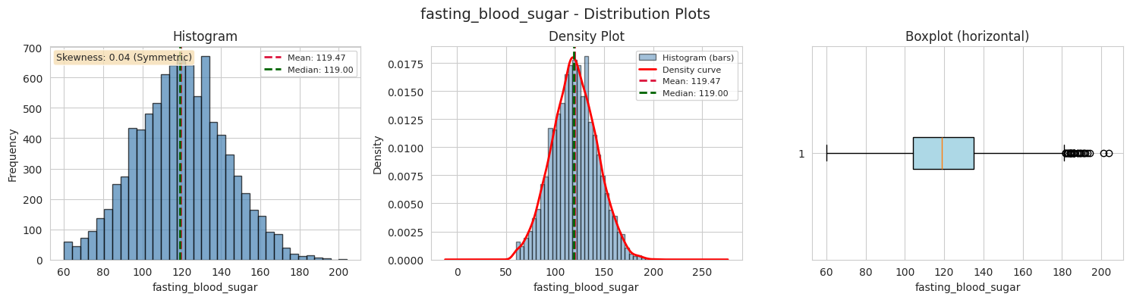
Figure: Histogram, density plot, and boxplot of fasting blood sugar.
- Shape: Symmetric (Skewness = 0.041)
- Mean = 119.47 | Median = 119.00 | difference = 0.47 (low -> symmetric)
- IQR = 31.00 (Q1 = 104.00, Q3 = 135.00)
- Outlier bounds: below 57.50 or above 181.50
- Outliers: 32 patients (0.4%)
Symmetric around 119 mg/dL (normal fasting sugar is below 100, so the sample leans slightly high). The 32 high-side outliers (above 181) are at diabetic levels.

3.9 HbA1c
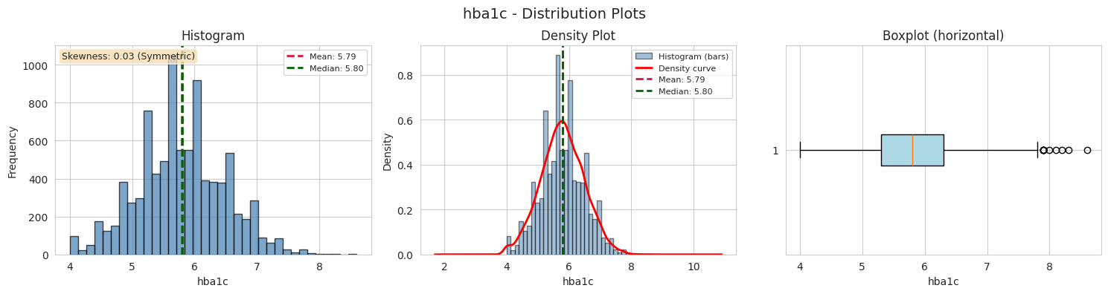
Figure: Histogram, density plot, and boxplot of hba1c.
- Shape: Symmetric (Skewness = 0.029)
- Mean = 5.79 | Median = 5.80 | difference = 0.01 (low -> symmetric)
- IQR = 1.00 (Q1 = 5.30, Q3 = 6.30)
- Outlier bounds: below 3.80 or above 7.80
- Outliers: 10 patients (0.1%)
Very tight and symmetric (IQR only 1.0). Just 10 high-side outliers (above 7.8) - HbA1c above 6.5 indicates diabetes, so these few patients are likely diabetic.

3.10 BMI
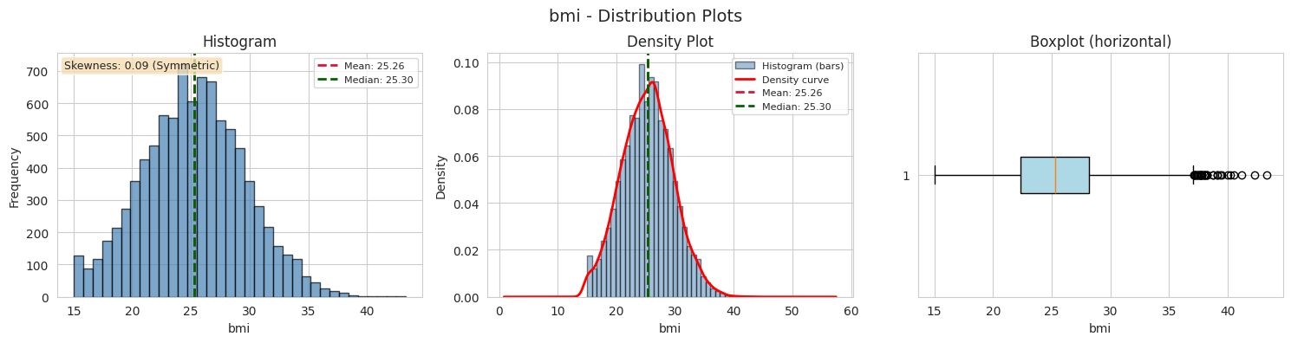
Figure: Histogram, density plot, and boxplot of bmi.
- Shape: Symmetric (Skewness = 0.092)
- Mean = 25.26 | Median = 25.30 | difference = 0.04 (low -> symmetric)
- IQR = 5.90 (Q1 = 22.30, Q3 = 28.20)
- Outlier bounds: below 13.45 or above 37.05
- Outliers: 39 patients (0.4%)
Roughly symmetric (skew ~ 0.09) with mean 25.3, just over the 'overweight' boundary. The 39 outliers are mostly on the high side (above 37) - obese patients.

3.11 Resting Heart Rate
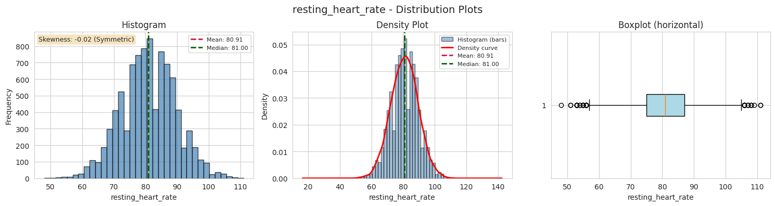
Figure: Histogram, density plot, and boxplot of resting heart rate.
- Shape: Symmetric (Skewness = -0.019)
- Mean = 80.91 | Median = 81.00 | difference = 0.09 (low -> symmetric)
- IQR = 12.00 (Q1 = 75.00, Q3 = 87.00)
- Outlier bounds: below 57.00 or above 105.00
- Outliers: 42 patients (0.5%)
Bell-shaped and symmetric around 81 bpm. The 42 outliers appear on both sides: very low rates (bradycardia, below 57) and very high rates (tachycardia, above 105).

3.12 Max Heart Rate Achieved
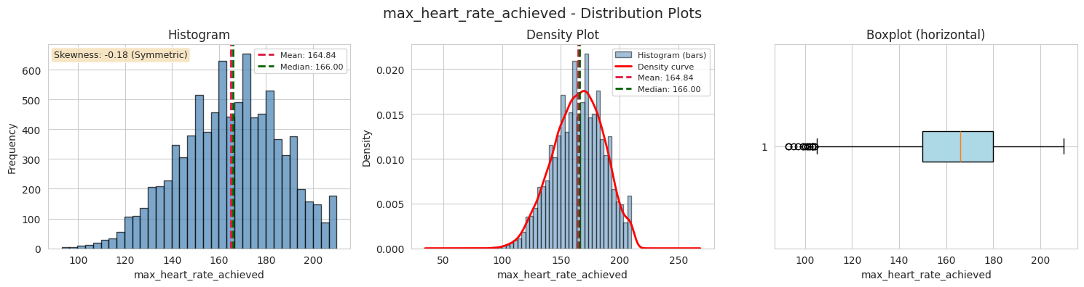
Figure: Histogram, density plot, and boxplot of max heart rate achieved.
- Shape: Symmetric (Skewness = -0.185)
- Mean = 164.84 | Median = 166.00 | difference = 1.16 (low -> symmetric)
- IQR = 30.00 (Q1 = 150.00, Q3 = 180.00)
- Outlier bounds: below 105.00 or above 225.00
- Outliers: 17 patients (0.2%)
Near-symmetric with a very slight left lean (skew ~ -0.19). Only 17 low-side outliers (below 105) - patients whose exercise capacity is limited, possibly by heart disease.

3.13 ST Depression
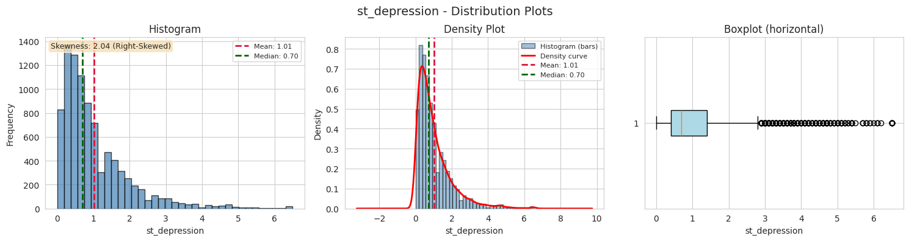
Figure: Histogram, density plot, and boxplot of st depression.
- Shape: Right-Skewed (Skewness = 2.041)
- Mean = 1.01 | Median = 0.70 | difference = 0.31 (mean > median -> Right-Skewed)
- IQR = 1.00 (Q1 = 0.40, Q3 = 1.40)
- Outlier bounds: below -1.10 or above 2.90
- Outliers: 485 patients (5.4%)
STRONGLY RIGHT-SKEWED (skew ~ 2.04): most patients have small values (median 0.70) but a few have very large ones. 485 outliers (5.4%) - the most of any feature. High ST depression is a classic ECG sign of heart disease, so these outliers are clinically meaningful.

3.14 Alcohol Units per Week
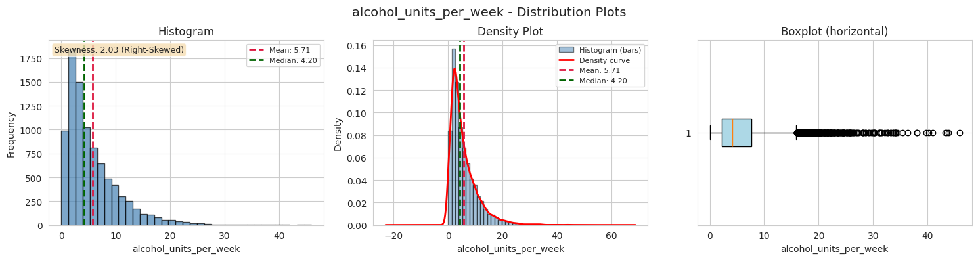
Figure: Histogram, density plot, and boxplot of alcohol units per week.
- Shape: Right-Skewed (Skewness = 2.027)
- Mean = 5.71 | Median = 4.20 | difference = 1.51 (mean > median -> Right-Skewed)
- IQR = 5.50 (Q1 = 2.20, Q3 = 7.70)
- Outlier bounds: below -6.05 or above 15.95
- Outliers: 431 patients (4.8%)
STRONGLY RIGHT-SKEWED (skew ~ 2.03): most people drink little (median 4.2 units/week) but a minority drink a lot. 431 outliers (4.8%) lie above 16 units/week.

3.15 Exercise Minutes per Week
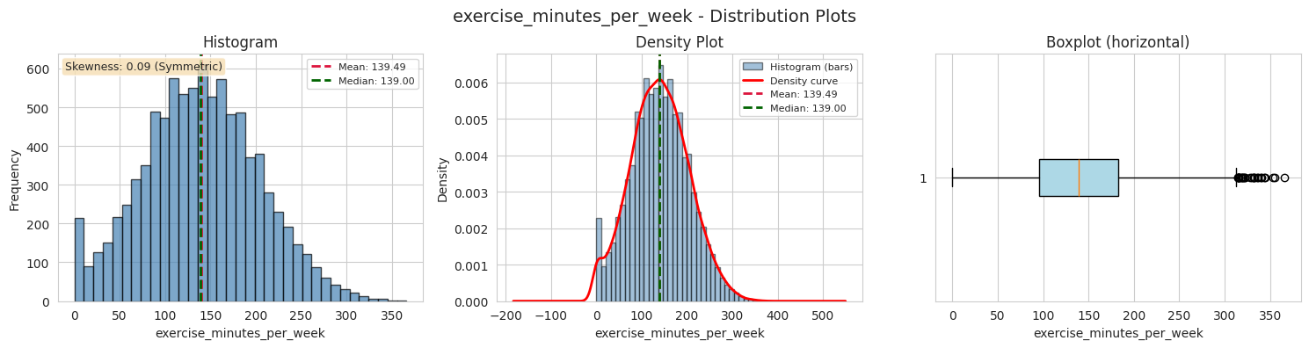
Figure: Histogram, density plot, and boxplot of exercise minutes per week.
- Shape: Symmetric (Skewness = 0.094)
- Mean = 139.49 | Median = 139.00 | difference = 0.49 (low -> symmetric)
- IQR = 87.00 (Q1 = 96.00, Q3 = 183.00)
- Outlier bounds: below -34.50 or above 313.50
- Outliers: 27 patients (0.3%)
Mean ~ median (both ~139), so the middle of the data is symmetric - but the mode is 0, meaning many patients do no exercise at all. The 27 high-side outliers are very active people (above 314 minutes/week).

3.16 Sleep Hours
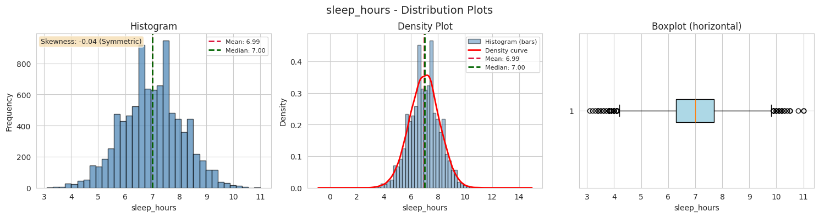
Figure: Histogram, density plot, and boxplot of sleep hours.
- Shape: Symmetric (Skewness = -0.042)
- Mean = 6.99 | Median = 7.00 | difference = 0.01 (low -> symmetric)
- IQR = 1.40 (Q1 = 6.30, Q3 = 7.70)
- Outlier bounds: below 4.20 or above 9.80
- Outliers: 86 patients (1.0%)
Symmetric around 7 hours (the recommended sleep duration). The 86 outliers sit at both extremes: very little sleep (below 4.2h) and very long sleep (above 9.8h).

3.17 Stress Score
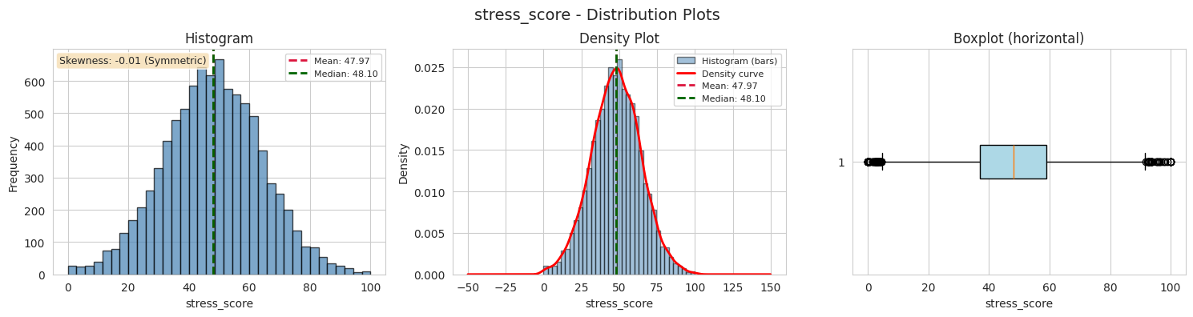
Figure: Histogram, density plot, and boxplot of stress score.
- Shape: Symmetric (Skewness = -0.013)
- Mean = 47.97 | Median = 48.10 | difference = 0.13 (low -> symmetric)
- IQR = 21.80 (Q1 = 37.10, Q3 = 58.90)
- Outlier bounds: below 4.40 or above 91.60
- Outliers: 71 patients (0.8%)
Symmetric around 48 (the middle of the 0-100 scale) with skew ~ -0.01. Only 71 outliers (0.8%), split on both sides.

3.18 Daily Steps
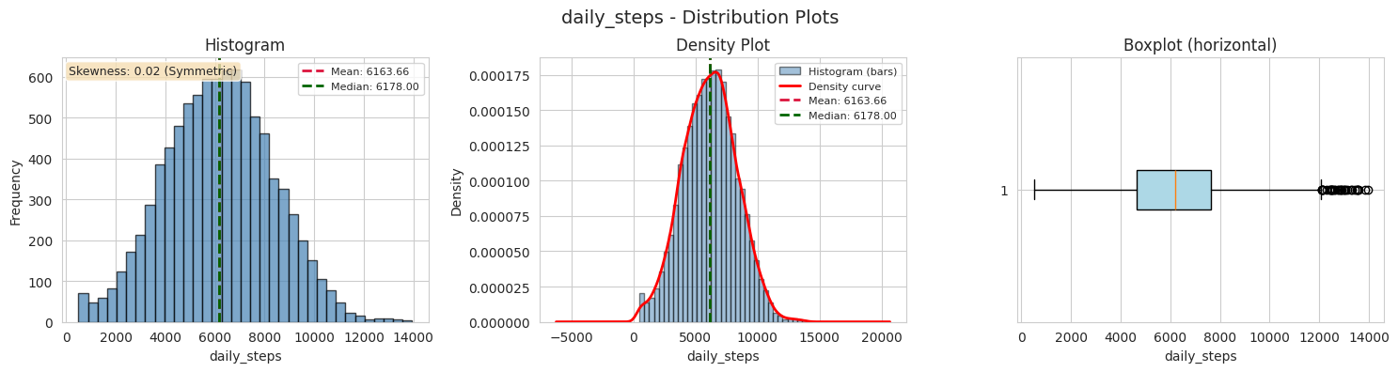
Figure: Histogram, density plot, and boxplot of daily steps.
- Shape: Symmetric (Skewness = 0.025)
- Mean = 6163.66 | Median = 6178.00 | difference = 14.34 (low -> symmetric)
- IQR = 2974.75 (Q1 = 4658.00, Q3 = 7632.75)
- Outlier bounds: below 195.88 or above 12094.88
- Outliers: 32 patients (0.4%)
Symmetric around ~6164 steps with the widest spread of all features (std ~ 2171). The mode of 500 shows many patients are very sedentary, and the 32 low-side outliers have near-zero step counts.

3.19 Diet Quality Score
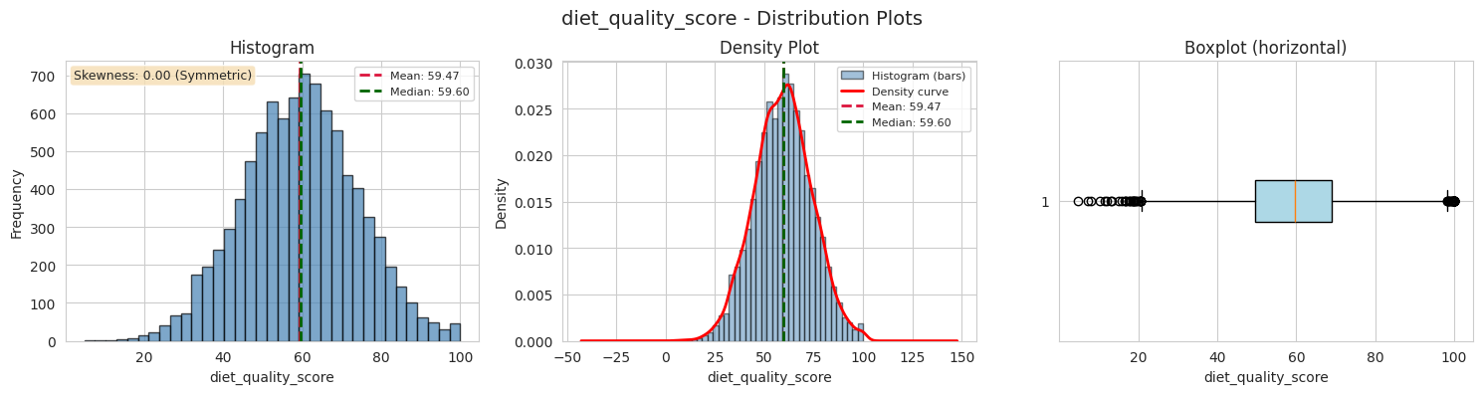
Figure: Histogram, density plot, and boxplot of diet quality score.
- Shape: Symmetric (Skewness = 0.001)
- Mean = 59.47 | Median = 59.60 | difference = 0.13 (low -> symmetric)
- IQR = 19.40 (Q1 = 49.70, Q3 = 69.10)
- Outlier bounds: below 20.60 or above 98.20
- Outliers: 69 patients (0.8%)
Perfectly symmetric (skew ~ 0.00) around 59.5 (middle of the 0-100 scale). The 69 outliers on both sides represent the extremes of diet quality.

3.20 Summary: Shape and Outliers for Every Numerical Feature
Feature | Skewness | Shape | Outliers (count) | Outliers (%)
age | -0.022 | Symmetric | 0 | 0
resting_bp_systolic | 0.068 | Symmetric | 66 | 0.73
resting_bp_diastolic | 0.009 | Symmetric | 75 | 0.83
cholesterol_total | 0.004 | Symmetric | 50 | 0.56
hdl | 0.02 | Symmetric | 63 | 0.7
ldl | 0.045 | Symmetric | 34 | 0.38
triglycerides | 0.126 | Symmetric | 42 | 0.47
fasting_blood_sugar | 0.041 | Symmetric | 32 | 0.36
hba1c | 0.029 | Symmetric | 10 | 0.11
bmi | 0.092 | Symmetric | 39 | 0.43
resting_heart_rate | -0.019 | Symmetric | 42 | 0.47
max_heart_rate_achieved | -0.185 | Symmetric | 17 | 0.19
st_depression | 2.041 | Right-Skewed | 485 | 5.39
alcohol_units_per_week | 2.027 | Right-Skewed | 431 | 4.79
exercise_minutes_per_week | 0.094 | Symmetric | 27 | 0.3
sleep_hours | -0.042 | Symmetric | 86 | 0.96
stress_score | -0.013 | Symmetric | 71 | 0.79
daily_steps | 0.025 | Symmetric | 32 | 0.36
diet_quality_score | 0.001 | Symmetric | 69 | 0.77

Part 3: Key Observations
- 17 out of 19 features are symmetric (skewness between −0.5 and +0.5) and their mean is almost equal to the median, so the typical patient is close to the average.
- Only two features are clearly right-skewed: st_depression (skew ≈ 2.04) with 5.4% outliers (the most of any feature), and alcohol_units_per_week (skew ≈ 2.03) with 4.8% outliers.
- All other features have less than ~1% outliers, so the dataset is quite clean and the outliers are the genuine extremes of patient health (hypertension, diabetes, obesity, etc.), not data-entry mistakes.
- The two right-skewed features, plus the zero-spikes in exercise_minutes_per_week and daily_steps (mode = 500), are the most interesting for later prediction because they capture the extremes of patient behavior and clinical risk.

Part 4 — Categorical Variable Analysis
Categorical variables cannot be averaged like numbers, so they are studied differently. For each categorical feature we build a frequency table (count and percentage per category), a bar chart, and a pie chart, then identify the most common category and comment on any imbalance in the data.

4.1 Sex
Category | Count | Percent
Male | 4731 | 52.57%
Female | 4269 | 47.43%

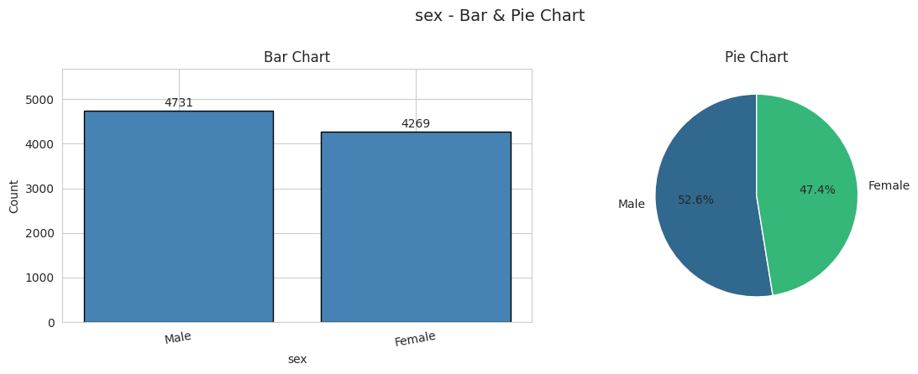
Figure: Bar chart and pie chart of sex.
- Most common category: Male (4731 patients, 52.6%)
Nearly balanced - Male (52.6%) vs Female (47.4%). No real imbalance, so sex should not bias the analysis.

4.2 Chest Pain Type
Category | Count | Percent
Asymptomatic | 4265 | 47.39%
Non-Anginal Pain | 2141 | 23.79%
Atypical Angina | 1576 | 17.51%
Typical Angina | 1018 | 11.31%

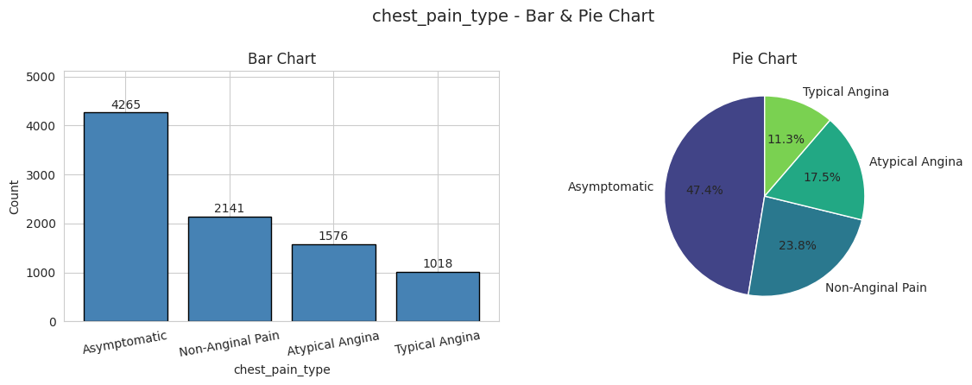
Figure: Bar chart and pie chart of chest pain type.
- Most common category: Asymptomatic (4265 patients, 47.4%)
ASYMMETRIC - Asymptomatic (47.4%) dominates; it has more patients than the other three categories combined. This is clinically important: many heart-disease patients have NO chest pain, so this variable alone is not enough to judge risk.

4.3 Exercise-Induced Angina
Category | Count | Percent
No | 6938 | 77.09%
Yes | 2062 | 22.91%

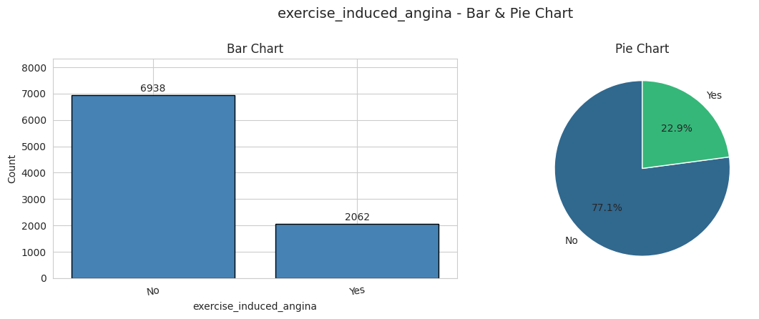
Figure: Bar chart and pie chart of exercise induced angina.
- Most common category: No (6938 patients, 77.1%)
Imbalanced - 77.1% No vs 22.9% Yes. The minority group (angina triggered by exercise) is still large enough (2062 patients) to study.

4.4 Family History
Category | Count | Percent
No | 6548 | 72.76%
Yes | 2452 | 27.24%

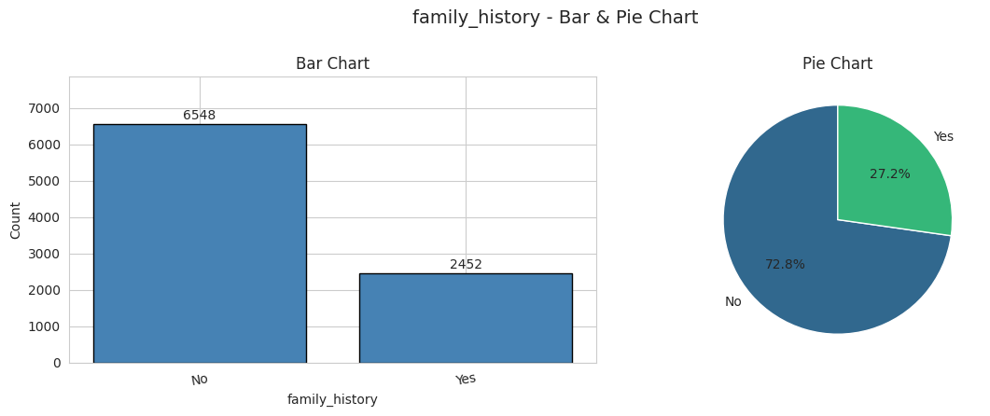
Figure: Bar chart and pie chart of family history.
- Most common category: No (6548 patients, 72.8%)
Imbalanced - 72.8% No vs 27.3% Yes. Only about one in four patients has a family history of heart disease.

4.5 Smoker Status
Category | Count | Percent
Never | 4980 | 55.33%
Former | 2448 | 27.2%
Current | 1572 | 17.47%

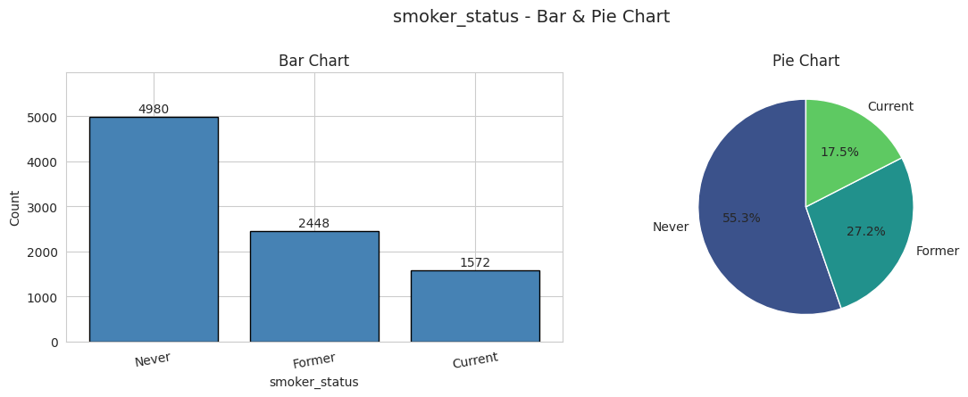
Figure: Bar chart and pie chart of smoker status.
- Most common category: Never (4980 patients, 55.3%)
Never (55.3%) is the most common, followed by Former (27.2%) and Current (17.5%). Reasonable spread, but current smokers are a clear minority.

4.6 Wearable Owner
Category | Count | Percent
No | 5015 | 55.72%
Yes | 3985 | 44.28%

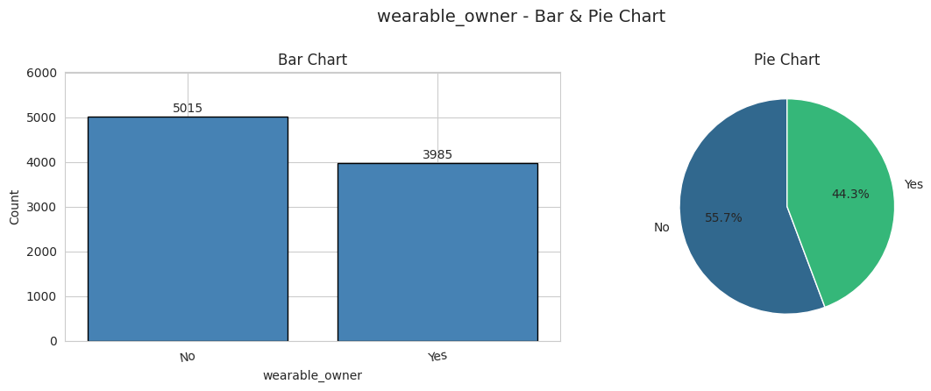
Figure: Bar chart and pie chart of wearable owner.
- Most common category: No (5015 patients, 55.7%)
Fairly balanced - 55.7% No vs 44.3% Yes. Good spread, so owning a wearable can be fairly compared between groups.

4.7 Has Heart Disease (Target Variable)
Category | Count | Percent
No | 6273 | 69.7%
Yes | 2727 | 30.3%

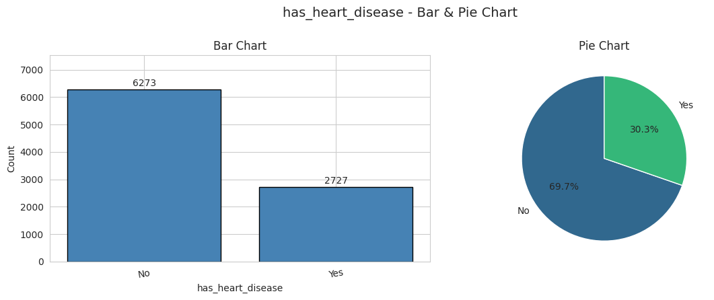
Figure: Bar chart and pie chart of has heart disease.
- Most common category: No (6273 patients, 69.7%)
Imbalanced - 69.7% No vs 30.3% Yes. This is the TARGET variable; the imbalance matters when we build a prediction model later (the model would otherwise just learn to predict 'No').

Part 4: Key Observations
- sex and wearable_owner are nearly balanced, so comparisons between groups are fair.
- chest_pain_type, exercise_induced_angina, family_history, and smoker_status are imbalanced; one category dominates in each.
- The target variable has_heart_disease is imbalanced (30.3% have the disease). This is the most important imbalance: a predictive model built later will need to handle it (e.g., with class weights or careful evaluation metrics).

Part 5 — Relationships Between Variables
This section explores how features relate to each other and to the target variable (has_heart_disease). Scatterplots are used for pairs of numerical variables (colored by heart disease status), and boxplots or count/proportion plots are used when one variable is the binary target, since a scatterplot against a binary variable would only draw two vertical strips of points. For every numerical pair, the Pearson correlation coefficient r is also reported (0.00–0.20 = very weak, 0.20–0.40 = weak, 0.40–0.60 = moderate, 0.60–0.80 = strong, 0.80–1.00 = very strong).

5.1 Age vs Total Cholesterol (colored by heart disease)
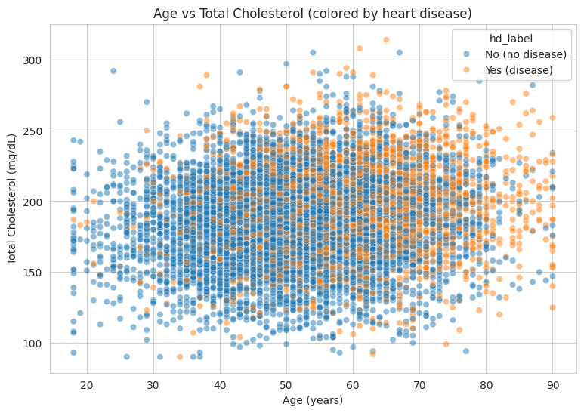
- Pearson correlation (age, cholesterol) = 0.128
age and cholesterol are only WEAKLY related (r = 0.128) - the points form a wide cloud with no clear line. Still, patients with disease tend to sit a bit higher: on average they are older (59.7 vs 51.5 years) and have slightly higher cholesterol (197 vs 185 mg/dL).

5.2 Age vs Total Cholesterol, split into Males and Females
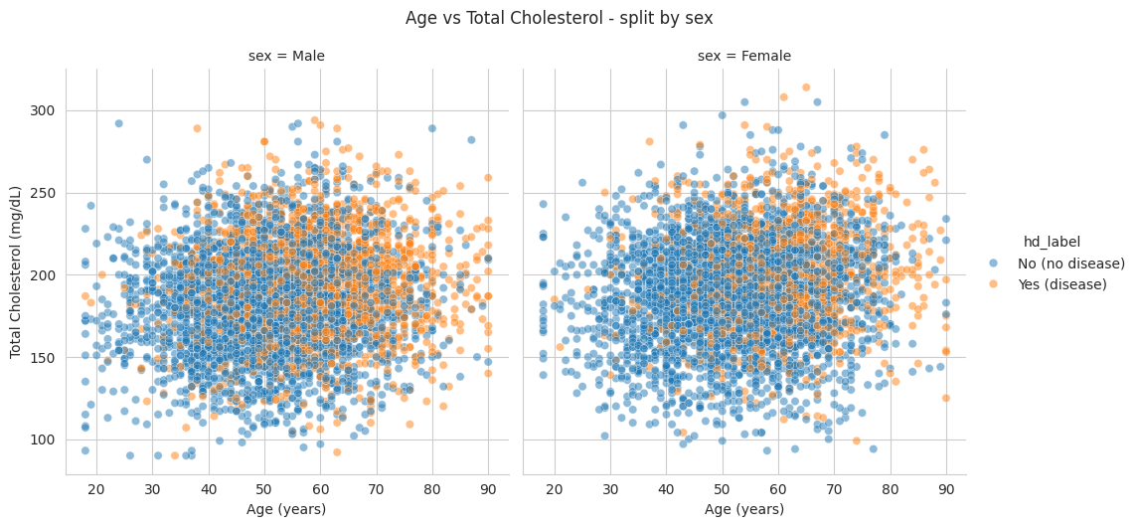
- Disease rate: Male = 35.4% | Female = 24.7%
the age-cholesterol pattern looks similar in both sexes, but males have a higher disease rate overall (35.4% vs 24.7%).

5.3 HDL (good cholesterol) vs LDL (bad cholesterol)
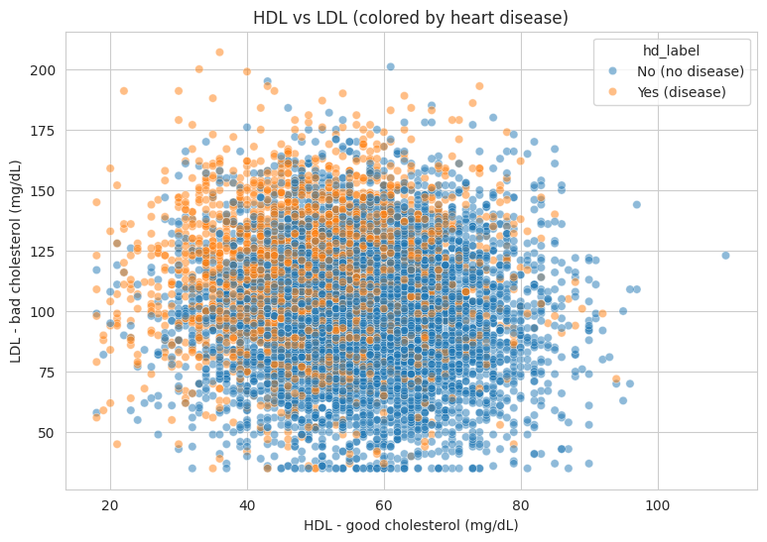
- Pearson correlation (hdl, ldl) = -0.082
- Mean HDL: no disease = 57.3 | with disease = 50.5
- Mean LDL: no disease = 98.5 | with disease = 114.4
HDL and LDL are almost uncorrelated (r = -0.082) - they are independent cholesterol measurements. The two groups separate clearly though: patients with disease have LOWER HDL (50.5 vs 57.3) and HIGHER LDL (114.4 vs 98.5). HDL is protective, LDL is harmful.

5.4 Age vs BMI, split into Males and Females
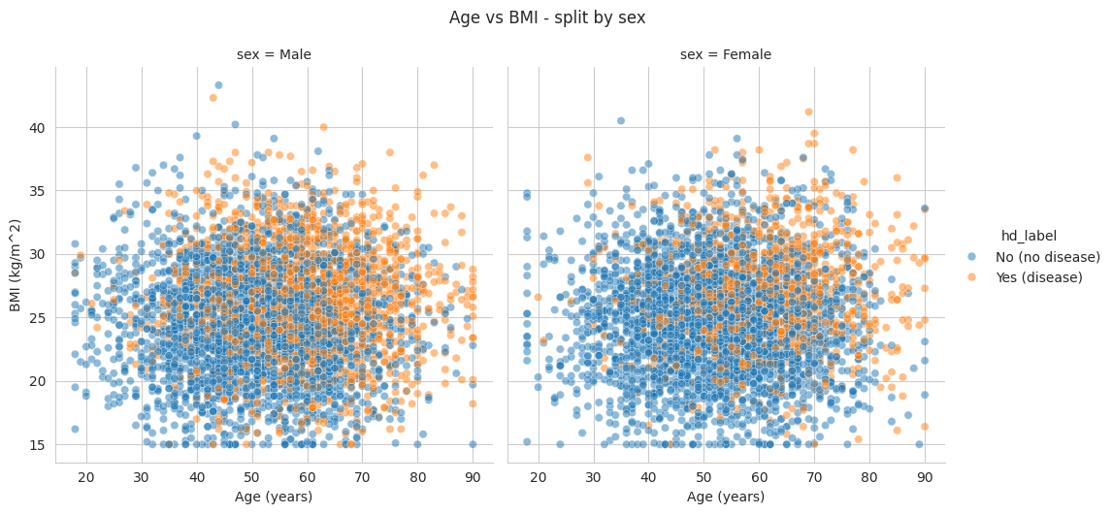
- Pearson correlation (age, bmi) = 0.039
age and BMI are basically INDEPENDENT (r = 0.039) - growing older does not automatically mean a higher BMI. In both sexes the disease group tends to have higher BMI.

5.5 BMI vs heart disease
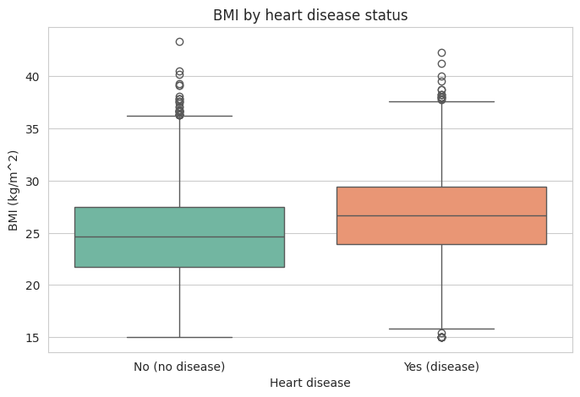
- sns.boxplot(data=df, x="hd_label", y="bmi", palette="Set2")
- Mean BMI: no disease = 24.65 | with disease = 26.68
- Pearson correlation (bmi, disease) = 0.213
patients with disease have a clearly higher average BMI (26.7 vs 24.7). The whole box shifts up, so excess weight is associated with heart disease.

5.6 Chest pain type vs heart disease
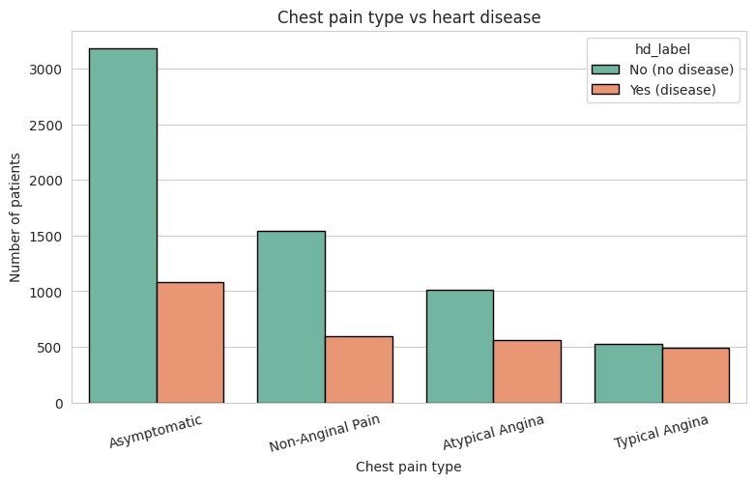
- Disease rate (%) within each chest pain type:
- chest_pain_type
- Asymptomatic 25.4
- Atypical Angina 35.5
- Non-Anginal Pain 27.8
- Typical Angina 47.9
- Name: has_heart_disease, dtype: float64
Typical Angina has by far the highest disease rate (47.9%), followed by Atypical Angina (35.5%), Non-Anginal Pain (27.8%) and Asymptomatic (25.4%). So the TYPE of chest pain is informative - but note Asymptomatic still contains the most patients overall.

5.7 Fasting blood sugar vs heart disease
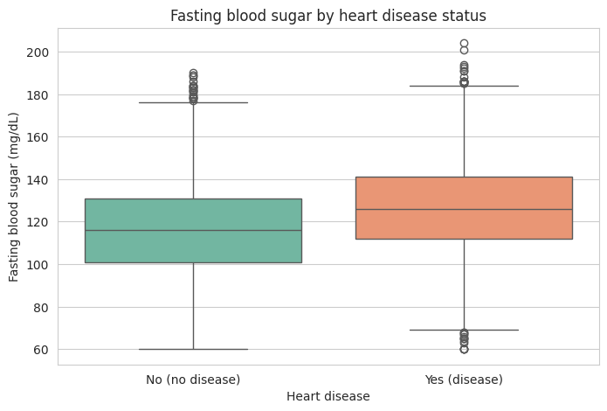
- sns.boxplot(data=df, x="hd_label", y="fasting_blood_sugar", palette="Set2")
- Mean sugar: no disease = 116.43 | with disease = 126.46
- Pearson correlation (sugar, disease) = 0.202
patients with disease have clearly higher fasting blood sugar (126.5 vs 116.4 mg/dL). High sugar / diabetes is a known risk factor for heart disease.

5.8 Family history vs heart disease
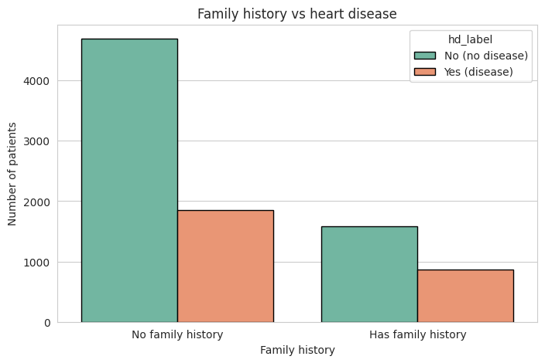
- Disease rate: no family history = 28.3% | with family history = 35.6%
patients with a family history of heart disease have a higher disease rate (35.6% vs 28.3%), so family history is a useful risk factor.

5.9 Resting blood pressure (systolic & diastolic) vs heart disease
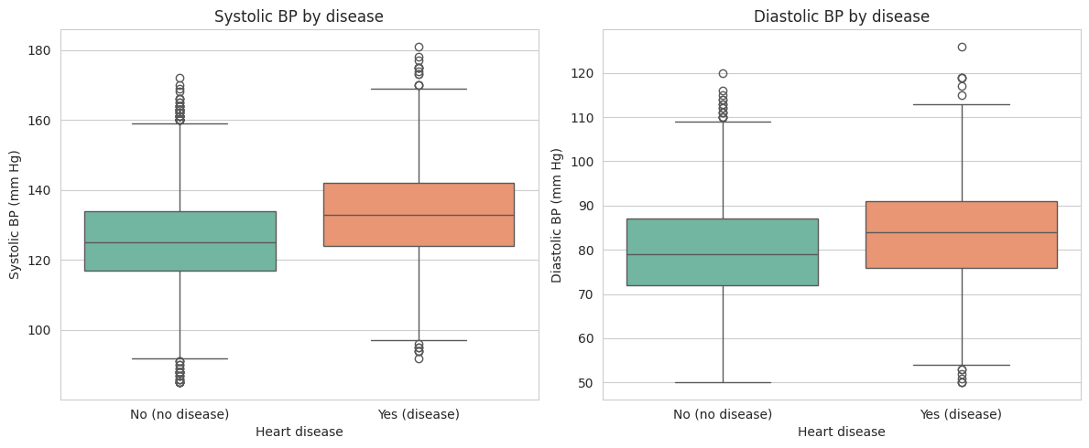
- sns.boxplot(data=df, x="hd_label", y="resting_bp_systolic", ax=axes[0], palette="Set2")
- sns.boxplot(data=df, x="hd_label", y="resting_bp_diastolic", ax=axes[1], palette="Set2")
- Mean systolic: no disease = 125.6 | with disease = 133.1 (r = 0.249)
- Mean diastolic: no disease = 79.4 | with disease = 84.0 (r = 0.193)
both systolic (133.1 vs 125.6) and diastolic (84.0 vs 79.4) blood pressure are higher in patients with disease. High blood pressure (hypertension) is a classic heart-disease risk factor.

5.10 Smoking status & alcohol vs heart disease
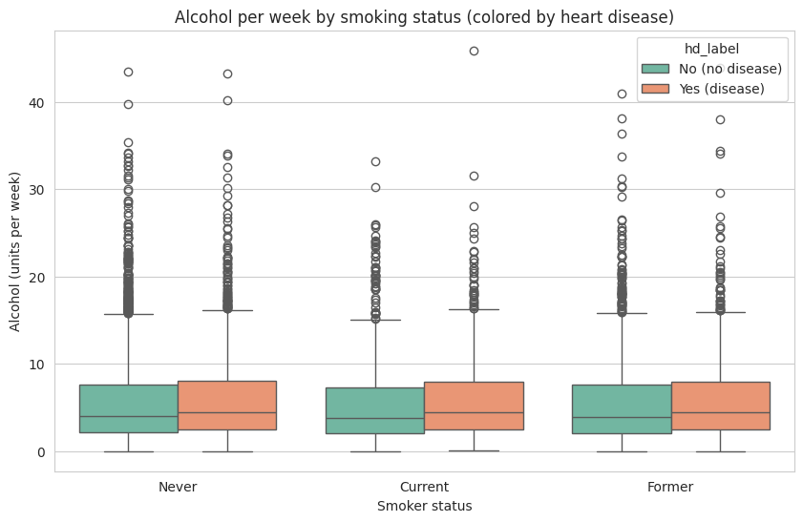
- Disease rate (%) by smoker status:
- smoker_status
- Current 46.4
- Former 30.3
- Never 25.2
- Name: has_heart_disease, dtype: float64
- Pearson correlation (alcohol, disease) = 0.041
Current smokers have the HIGHEST disease rate (46.4%), then Former (30.3%) and Never smokers (25.2%). Alcohol is a much weaker factor: its correlation with disease is only 0.041 and the median alcohol levels look similar across smoker groups.

5.11 Summary: Correlation with Heart Disease
The table below lists the Pearson correlation of every numerical feature with the target variable, sorted from strongest to weakest by absolute value.
Feature | Correlation with Disease (r)
max_heart_rate_achieved | -0.581
st_depression | 0.357
age | 0.291
ldl | 0.267
hdl | -0.252
resting_bp_systolic | 0.249
exercise_minutes_per_week | -0.248
hba1c | 0.226
bmi | 0.213
fasting_blood_sugar | 0.202
resting_bp_diastolic | 0.193
resting_heart_rate | 0.168
cholesterol_total | 0.168
diet_quality_score | -0.155
daily_steps | -0.153
triglycerides | 0.11
stress_score | 0.098
sleep_hours | -0.05
alcohol_units_per_week | 0.041

5.12 Correlation Matrix (All Numerical Features + Target)
A correlation matrix shows all pairwise correlations at once as a heatmap. The last row and column (has_heart_disease) show how every numerical feature relates to heart disease; the rest of the grid shows how the features relate to each other.
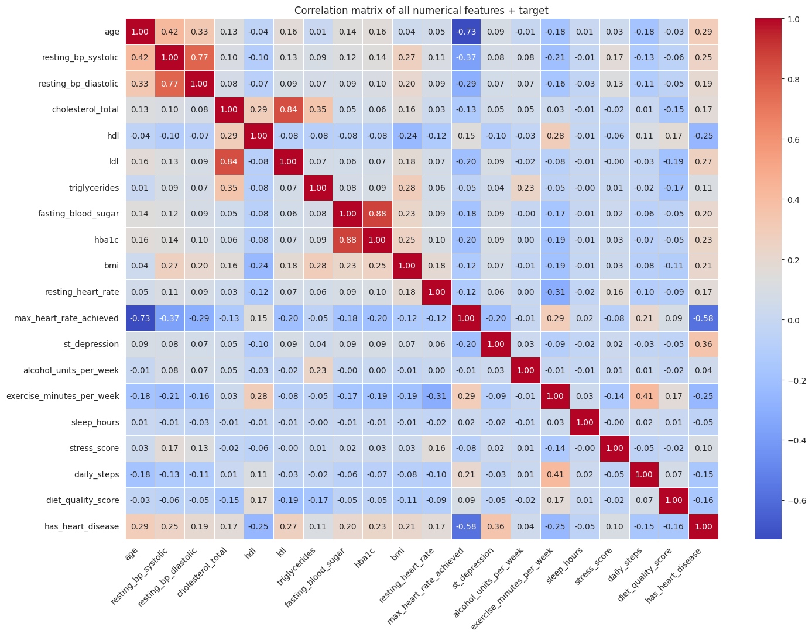
Figure: Pearson correlation matrix of all numerical features and the target variable.
Reading the matrix:
- Last row/column (correlation with heart disease): the strongest values are max_heart_rate_achieved (r = −0.58), st_depression (r = +0.36), age (r = +0.29), ldl (r = +0.27), hdl (r = −0.25), and resting_bp_systolic (r = +0.25). This matches the summary table in Section 5.11.
- Feature vs. feature: resting_bp_systolic and resting_bp_diastolic are strongly correlated (r ≈ 0.5), which is expected since they are measured together. hdl is negatively correlated with triglycerides, and the cholesterol-related features (cholesterol_total, ldl, hdl, triglycerides) form a small cluster, meaning they partly overlap as predictors.

Part 5: Key Observations
Strongest relationships with heart disease:
- max_heart_rate_achieved (r = −0.58, negative): patients with disease reach a much lower maximum heart rate during exercise — the strongest signal in the whole dataset.
- st_depression (r = +0.36): higher ST depression goes with more disease.
- age (r = +0.29), ldl (r = +0.27), hdl (r = −0.25), systolic BP (r = +0.25).
Weakest relationships:
- alcohol_units_per_week (r ≈ 0.04), age vs bmi (r ≈ 0.04), and hdl vs ldl (r ≈ −0.08) — these pairs are effectively independent.
Clear categorical patterns:
- Typical Angina (47.9% disease rate), current smokers (46.4%), and family history (35.6%) all raise the disease rate noticeably.
The variables that separate the two groups best (max_heart_rate_achieved, st_depression, age, cholesterol fractions, blood pressure) are the ones that would be fed into a future predictive model.

Part 6 — Data Quality Assessment
Good statistics start with clean data. This section checks the dataset for three common problems: missing values (empty cells that force a decision to drop or impute), duplicate rows (the same patient appearing more than once, which would double-count that patient), and unusual/impossible values (numbers that cannot be real, such as a negative BMI, which are usually data-entry errors). Note the distinction from Part 3: the IQR outliers found earlier are statistically unusual but can still be real patients (e.g., high blood pressure, obesity); the impossible values checked here are physically impossible and are almost certainly errors.

6.1 Missing Values
Every one of the 27 columns was checked for missing (NaN) values using df.isna().sum(). The result: 0 missing values in every column, and 0 missing values in the whole dataset.

6.2 Duplicate Rows
The dataset was checked for exact duplicate rows using df.duplicated().sum(). The result: 0 duplicate rows. No patient is counted twice.

6.3 Unusual / Impossible Values
The minimum and maximum of every numerical column were inspected for impossible values (e.g., negative blood pressure, BMI below zero). No column contained negative values, and the ranges observed were all clinically plausible:
Feature | Min | Max
age | 18.00 | 90.00
resting_bp_systolic | 85.00 | 181.00
resting_bp_diastolic | 50.00 | 126.00
cholesterol_total | 90.00 | 314.00
hdl | 18.00 | 110.00
ldl | 35.00 | 207.00
triglycerides | 35.00 | 390.00
fasting_blood_sugar | 60.00 | 204.00
hba1c | 4.00 | 8.60
bmi | 15.00 | 43.30
resting_heart_rate | 48.00 | 111.00
max_heart_rate_achieved | 93.00 | 210.00
st_depression | 0.00 | 6.50
alcohol_units_per_week | 0.00 | 45.90
exercise_minutes_per_week | 0.00 | 366.00
sleep_hours | 3.10 | 11.00
stress_score | 0.00 | 100.00
daily_steps | 500.00 | 13950.00
diet_quality_score | 4.80 | 100.00

A sensible clinical range was also defined for each numerical column (e.g., age between 0–120 years, systolic BP between 50–260 mmHg), and every value in the dataset fell inside its expected range. In addition, every categorical column (sex, chest_pain_type, smoker_status) was checked against its list of expected categories, and no unexpected categories (e.g., typos) were found.

6.4 Discussion: What Was Found and How Issues Would Be Handled
Result: the dataset is completely clean.
- Missing values: 0 in every column. Nothing to impute.
- Duplicate rows: 0. No patient is counted twice.
- Impossible values: none. Every numerical column sits inside a clinically plausible range, there are no negative values, and every categorical column contains only the expected categories.
How these issues would be handled if they were found:
- Missing values reduce the sample size and can bias the averages. Options are to drop the affected rows (safe when only a few rows are affected) or impute (fill with the median, best for skewed data, mean, or mode).
- Duplicate rows would make one patient count twice in every table and plot, over-weighting that patient. They would simply be dropped (df.drop_duplicates()).
- Impossible values (e.g., BP = 0, negative BMI) are usually entry errors. They can be corrected, replaced with the median, or the row removed; otherwise they can drag the mean and correlations in the wrong direction.
Important note about the Part 3 outliers: the IQR outliers identified earlier (e.g., high ST depression, obesity, very heavy drinking) are extreme but real patients, not data errors, and should be kept in the analysis because they represent exactly the high-risk group of interest.
Part 6 conclusion: No data cleaning is needed before modeling — the dataset is ready to use as it is.

Part 7 — Key Insights
Having described the dataset, measured its center and spread, examined the shape of every distribution, analyzed the categorical variables, explored how features relate to each other and to heart disease, and confirmed the data quality, this final section brings together the most important findings.

7.1 The Typical Patient Profile of Heart Disease
Comparing patients with disease against those without, the disease group is clearly different on almost every clinical measurement:
Feature | No Disease | With Disease | Direction
Age (years) | 51.5 | 59.7 | older
Systolic BP (mmHg) | 125.6 | 133.1 | higher
Diastolic BP (mmHg) | 79.4 | 84.0 | higher
LDL — bad cholesterol (mg/dL) | 98.5 | 114.4 | higher
HDL — good cholesterol (mg/dL) | 57.3 | 50.5 | lower
BMI (kg/m²) | 24.7 | 26.7 | higher
Fasting blood sugar (mg/dL) | 116.4 | 126.5 | higher

The risk profile is coherent: older age, worse cholesterol balance, higher blood pressure, higher weight, and higher blood sugar all go together with heart disease — exactly the risk factors doctors look for in real life.

7.2 The Strongest Single Signals in the Data
- max_heart_rate_achieved (r = −0.58): by far the most informative feature. Patients with disease reach a much lower maximum heart rate during exercise, which makes sense — heart disease limits physical capacity.
- st_depression (r = +0.36): a classic ECG sign of heart disease; also the most right-skewed feature in the dataset.
- Age (r = +0.29), LDL (r = +0.27), HDL (r = −0.25), systolic BP (r = +0.25).

7.3 Categorical and Lifestyle Insights
Variable | Group | Disease Rate (%)
chest_pain_type | Asymptomatic | 25.4
chest_pain_type | Atypical Angina | 35.5
chest_pain_type | Non-Anginal Pain | 27.8
chest_pain_type | Typical Angina | 47.9
smoker_status | Current | 46.4
smoker_status | Former | 30.3
smoker_status | Never | 25.2
sex | Female | 24.7
sex | Male | 35.4
family_history | No | 28.3
family_history | Yes | 35.6

- Chest pain type is informative: Typical Angina → 47.9% disease rate vs Asymptomatic → 25.4% (though Asymptomatic remains the most common type overall, as noted in Part 4).
- Smoking matters a lot: current smokers → 46.4% disease rate vs never-smokers → 25.2%.
- Family history → 35.6% vs 28.3% without.
- Sex: males 35.4% vs females 24.7%.
- Alcohol is a weak factor (r = 0.04), far less important than smoking in this dataset.

7.4 Variables Most Useful for Future Predictive Modeling
Strong candidates (keep):
max_heart_rate_achieved, st_depression, age, ldl, hdl, resting_bp_systolic, exercise_minutes_per_week, hba1c, bmi, fasting_blood_sugar, and the categorical variables chest_pain_type, smoker_status, family_history, and sex.
Weakest candidates (least useful):
alcohol_units_per_week (r ≈ 0.04), sleep_hours (r ≈ −0.05), stress_score (r ≈ 0.10), and triglycerides (r ≈ 0.11).
Modeling warning:
The target is imbalanced — only 30.3% of patients have heart disease. A model that always predicts "no disease" would be ~70% "accurate" while learning nothing, so a future model must be evaluated with care (e.g., precision/recall or balanced metrics), not plain accuracy.

7.5 Final Conclusion
The dataset tells one coherent clinical story: heart disease is associated with older age, a worse cholesterol profile, higher blood pressure, higher BMI, higher blood sugar, lower exercise capacity, smoking, and certain chest-pain types. The data is completely clean (no missing values, no duplicates, no impossible values), so these patterns are trustworthy. This exploratory analysis provides an excellent starting point for building a predictive model in the next stage of the course.

Part 8 — Predictive Modeling
This part extends the exploratory analysis from Part 1 by applying predictive models to the Heart Disease Risk 2026 dataset (9,000 patients, 27 columns). Part 1 found the dataset to be clean, with no missing values, no duplicates, and no impossible values, and identified clear signals: low max heart rate, high ST depression, older age, high LDL, low HDL, and high blood pressure all associate with heart disease. This part builds two required models — Linear Regression (a regression task) and Logistic Regression (a classification task) — and compares them against four additional models (k-Nearest Neighbors, Decision Tree, Random Forest, and Naive Bayes).

8.1 Recap of Part 1 and Data Preparation
Recap of Part 1: 9,000 patients, 27 columns, no missing values, no duplicates. The target has_heart_disease is imbalanced: 1 = disease (2,727 patients, 30.3%), 0 = no disease (6,273 patients, 69.7%), which matters when judging the classification models. The strongest numeric signals with disease were max_heart_rate_achieved (r = −0.58), st_depression (r = +0.36), age (r = +0.29), ldl (r = +0.27), hdl (r = −0.25), and resting_bp_systolic (r = +0.25). The strongest categorical signals were chest pain type (Typical Angina, 47.9% disease rate), current smokers (46.4%), family history (35.6%), and sex (males 35.4% vs females 24.7%).
Preparing the data: models only accept numbers, so the text categories (sex, chest_pain_type, smoker_status) were converted into dummy (0/1) columns using pd.get_dummies(drop_first=True), and the True/False columns (exercise_induced_angina, family_history, wearable_owner) were converted to 0/1. patient_id was excluded since it is only an identifier, not a real feature. This produced a feature table of 9,000 rows and 26 columns (19 numerical features plus 7 dummy columns from the categorical features), with the target y = has_heart_disease.

8.2 Train-Test Splitting Methodology
The dataset was split into a training set (80%) and a testing set (20%) using scikit-learn's train_test_split. Models are fitted (learn) only on the training set, then evaluated on the testing set, which they have never seen — this shows how the model would perform on new patients. The split uses random_state = 42 so it is reproducible. For the classification task, stratify = y is used so that the same 30.3% disease rate is preserved in both the training and testing sets — important because the target is imbalanced. This produced 7,200 training patients and 1,800 testing patients, with the positive rate held at 30.3% in both.

8.3 Linear Regression (Regression Task)

Choosing the target and the feature
The assignment requires a regression task on an appropriate numerical feature. The target chosen is max_heart_rate_achieved (the highest heart rate reached during exercise, in bpm) — a continuous numerical variable, exactly what regression is designed to predict. The predictor feature is age (in years). There is a well-known medical rule of thumb that maximum heart rate falls with age (roughly 220 minus age), and Part 1 already found a strong correlation between the two (r = −0.73), so a straight-line fit was expected to work well: max_heart_rate = b0 + b1 × age.

Manual implementation vs scikit-learn
The instructor requires Linear Regression to be implemented both manually and with scikit-learn. The manual version solves the normal equation β = (XᵀX)⁻¹Xᵀy directly with np.linalg.inv, trained on the same 80/20 training split (this split used random_state = 42 without stratification, since it is a regression task). The manual model and the scikit-learn LinearRegression model produced identical results on the testing set, confirming the manual implementation is correct.
Method | Intercept | Slope (age) | MSE | RMSE | R²
Manual (normal equation) | 229.6355 | -1.2006 | 216.43 | 14.71 | 0.524
scikit-learn LinearRegression | 229.6355 | -1.2006 | 216.43 | 14.71 | 0.524

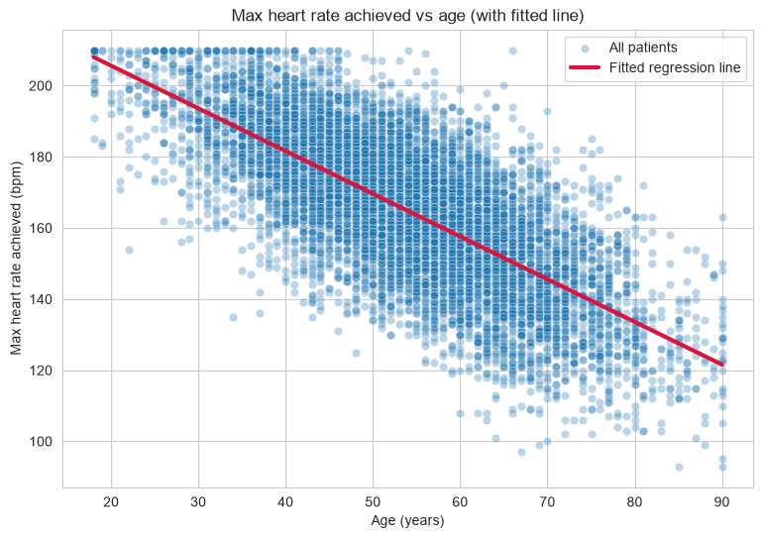
Figure: Max heart rate achieved vs age, with the fitted regression line.
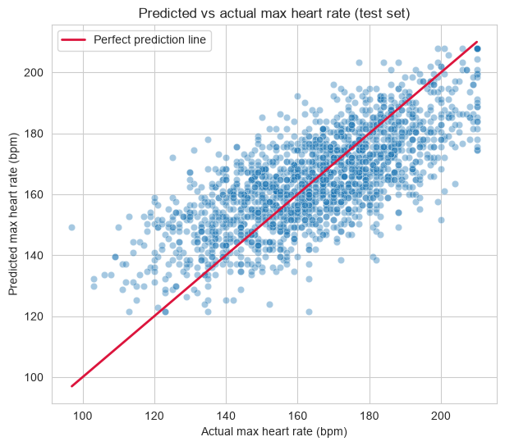
Figure: Predicted vs actual max heart rate on the testing set (simple linear regression).

Reading the simple linear regression results
- Fitted line: max_heart_rate = 229.64 − 1.20 × age. Each extra year of age lowers the predicted max heart rate by about 1.2 bpm on average, matching the medical rule of thumb.
- MSE = 216.43, RMSE = 14.71: on the testing set, predictions are off by about 14.7 bpm on average. Heart rate also depends on fitness, medication, and other factors not in the dataset, so a single-feature model cannot be exact.
- R-squared = 0.524: age alone explains about 52% of the variation in max heart rate — strong for a single feature, and consistent with the r = −0.73 correlation found in Part 1.

Improving the model: multiple linear regression
To try to reduce the error, five more clinical features were added — bmi, resting_bp_systolic, hba1c, resting_heart_rate, and sex_Male — using the same technique with more than one predictor, evaluated on the same 80/20 split.
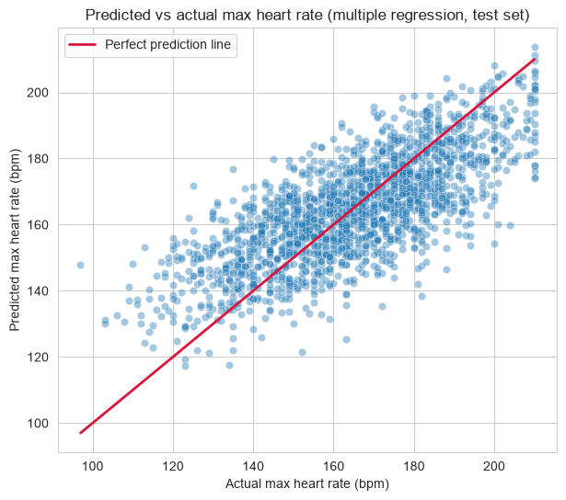
Figure: Predicted vs actual max heart rate on the testing set (multiple regression, 6 features).

What if we use all the features?
The regression was then re-fit using the full feature table (25 features — every numerical feature and dummy column except max_heart_rate_achieved itself, which was dropped to avoid data leakage since it is the target).
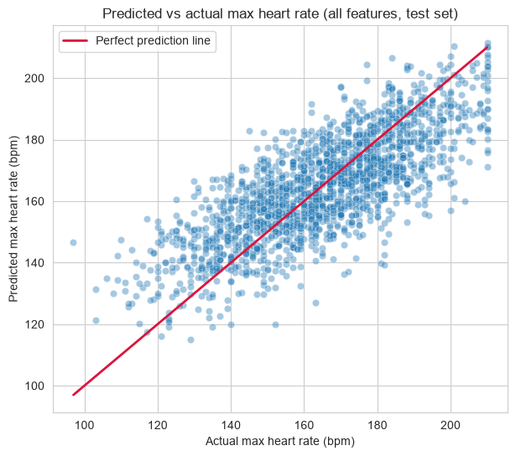
Figure: Predicted vs actual max heart rate on the testing set (all-features regression).
Model | MSE | RMSE | R²
Simple (age only) | 216.43 | 14.71 | 0.524
Multiple (6 features) | 207.17 | 14.39 | 0.545
Multiple (all features) | 185.02 | 13.60 | 0.594

Adding the 6 clinical features only helped a little (RMSE 14.71 → 14.39, R² 0.524 → 0.545); the age coefficient (−1.14) is still doing most of the work, so more features is not automatically better when one strong predictor already carries the pattern. Using all the features did help more (RMSE down to 13.60, R² up to 0.594). The largest coefficients came from exercise_induced_angina (−5.40, patients with exercise-induced chest pain reach a clearly lower max heart rate), chest_pain_type_Typical Angina (−3.38), smoker_status_Never (+2.05), st_depression (−1.81), sex_Male (−1.51), and age (−1.08). Features such as daily steps, triglycerides, fasting blood sugar, alcohol, cholesterol, and resting blood pressure contributed almost nothing once the other features were included.

8.4 Logistic Regression (Classification Task)

Choosing the target and the features
The classification target is has_heart_disease (1 = disease, 0 = no disease) — a binary categorical target, exactly what logistic regression is designed for. All numerical features and encoded categorical columns were used together; logistic regression combines them into a single probability between 0 and 1 for each patient. Because several features separate the two groups clearly (Part 1), a logistic model was expected to work well. Since the target is imbalanced (only 30.3% disease), plain accuracy can be misleading — a model that always predicts “no disease” would already be about 70% “accurate.” Alongside accuracy, the F1 score, confusion matrix, and ROC-AUC are reported.
Logistic regression is sensitive to feature scale, so every feature was standardised (mean 0, standard deviation 1) using StandardScaler, fit on the training set only and then applied to the testing set, using the same 80/20 stratified split described in Section 2.2.
Metric | Value
Accuracy | 0.8972
Precision | 0.8614
Recall | 0.7872
F1 score | 0.8226
ROC-AUC | 0.9497

Confusion Matrix | Predicted: No Disease | Predicted: Disease
Actual: No Disease | 1186 | 69
Actual: Disease | 116 | 429

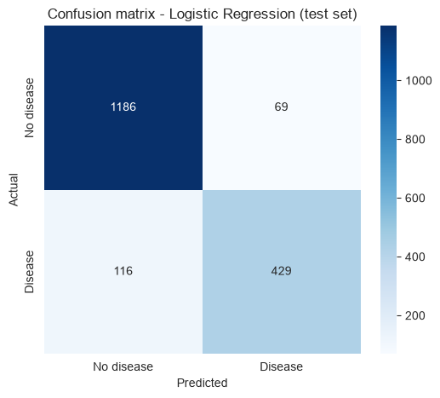
Figure: Confusion matrix — Logistic Regression (testing set).
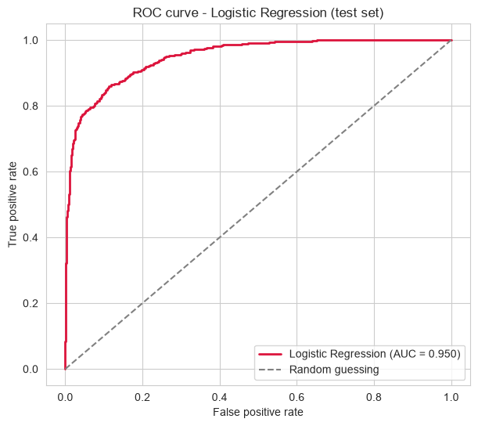
Figure: ROC curve — Logistic Regression (testing set).

Reading the logistic regression results
- Accuracy = 0.897: about 90% of test patients were classified correctly. This looks high, but the target is imbalanced — a naive model that always predicts “no disease” would already reach about 70% accuracy, so accuracy alone is not enough.
- F1 score = 0.823 is the better measure here, balancing precision = 0.861 (when the model says “disease,” it is correct about 86% of the time) and recall = 0.787 (the model catches about 79% of patients who actually have disease).
- Confusion matrix: of the 1,800 test patients, the model found 429 of the 545 real disease patients (116 missed, false negatives) and wrongly flagged only 69 healthy patients (false positives). In medicine, missing a disease patient is the more dangerous error, so the fairly high recall is reassuring.
- ROC-AUC = 0.950: the model ranks a random disease patient higher than a random healthy patient about 95% of the time — the two groups are clearly well separated, matching the strong signals found in Part 1.

8.5 Additional Models (Optional)
Four more classification models were tried and compared with Logistic Regression, all using the same scaled training and testing sets for a fair comparison: k-Nearest Neighbors (kNN) classifies a patient by looking at the 5 closest training patients; Decision Tree splits patients with simple if-then rules (depth limited to 5 to avoid overfitting); Random Forest builds 100 decision trees and averages their votes; and Naive Bayes is a simple probabilistic model based on Bayes' rule that assumes the features are independent.
Model | Accuracy | Precision | Recall | F1 score
Logistic Regression | 0.897 | 0.861 | 0.787 | 0.823
Random Forest | 0.881 | 0.853 | 0.732 | 0.788
Naive Bayes | 0.870 | 0.769 | 0.817 | 0.792
kNN (k = 5) | 0.855 | 0.860 | 0.622 | 0.722
Decision Tree (depth 5) | 0.854 | 0.800 | 0.692 | 0.742

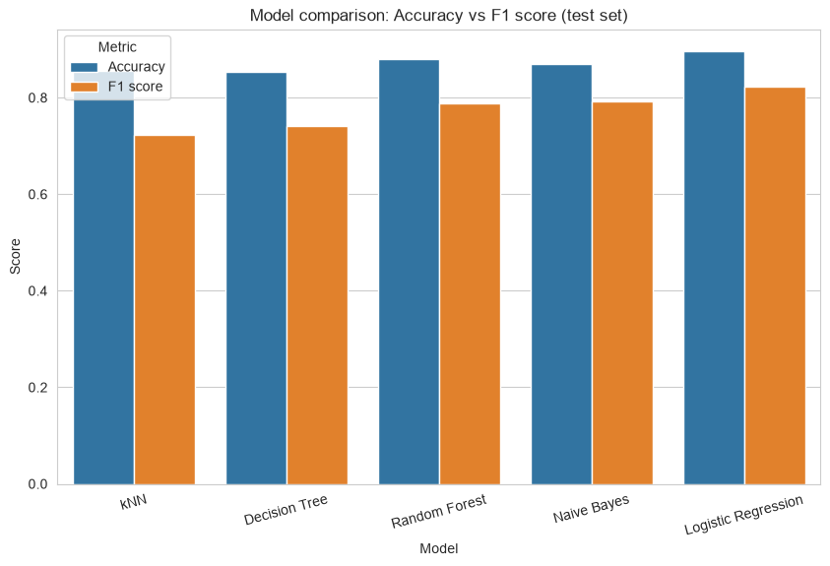
Figure: Model comparison — Accuracy vs F1 score across all five models (testing set).
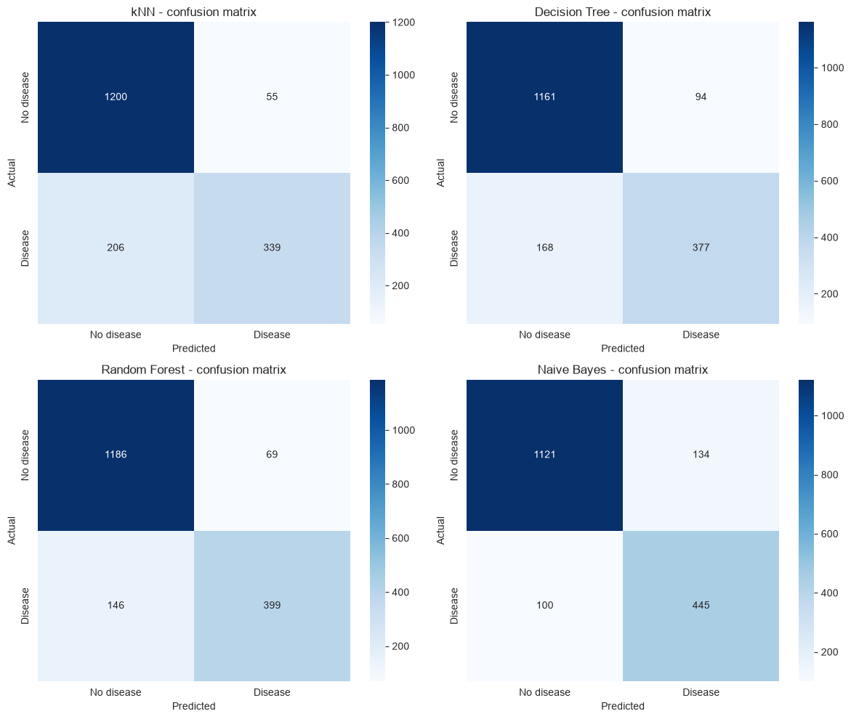
Figure: Confusion matrices of the four additional models (testing set).

Reading the additional model results
- Logistic Regression is the best overall on both F1 (0.823) and accuracy (0.897). This makes sense: the data is “linearly friendly” (the features separate the groups smoothly, shown by the AUC of 0.95), so the simple linear model beats the more complex ones.

- Random Forest comes second (F1 0.788). It is more flexible, but here the extra flexibility does not help much and trees can overfit the training noise.

- Naive Bayes has the highest recall (0.817): it is aggressive at calling disease, missing fewer real patients, but at the cost of lower precision (0.769) — more healthy patients are wrongly flagged.

- kNN and the Decision Tree are the weakest. kNN suffers because the “no disease” majority dominates its nearest neighbours, and a depth-5 tree is too simple to capture the full pattern in this data.

2.6 Results and Discussion

What the results indicate
The models agree with the Part 1 findings: heart disease in this dataset is very predictable. Logistic regression reaches ROC-AUC = 0.95 and F1 = 0.82, which is strong for a healthcare classification task. The regression model also behaved as expected: age explains about 52% of the variation in max heart rate, and the fitted slope (about −1.2 bpm per year) matches the medical rule of thumb.

Is the performance good or poor, and why
The performance is good, mainly because the dataset is clean and the features are informative:
- No missing values, duplicates, or impossible values (Part 1), so the models were never disturbed by dirty input.
- The strongest predictors (max heart rate, ST depression, age, cholesterol fractions, blood pressure) separate the two groups clearly, which is why the AUC is so high.
- The 30.3% target imbalance did not hurt much here because the signal is strong, though it still matters for evaluation — this is why F1 and ROC-AUC were relied on rather than accuracy alone.

Limitations and issues
- Class imbalance: a naive model that always predicts “no disease” would already reach about 70% accuracy, which is why the models were never judged on accuracy alone.
- Synthetic data: the dataset is artificially generated (Kaggle, “Heart Disease Risk 2026”). Real clinical data is noisier, so these exact numbers would likely not transfer directly to real patients.
- The regression is approximate: it predicts max heart rate with an RMSE of about 14 bpm. Heart rate also depends on fitness, medication, and other factors not in the dataset.
- False negatives: in medicine, missing a real heart-disease patient is the most dangerous error. The logistic model still misses about 21% of disease patients (116 of 545 in the testing set); a higher-recall model such as Naive Bayes catches more, at the price of more false alarms.

How the dataset characteristics affected the results
The clean, well-separated data is the main reason all models performed well. Because the classes are nearly linearly separable (AUC 0.95 for logistic regression), the simplest model wins; complex models such as Random Forest or kNN never get a real chance to show an advantage. If the data were noisier or more overlapping, the tree-based models might catch up.

8.7 Conclusions and Key Findings
- Linear Regression modelled the relationship between age and max heart rate (RMSE ≈ 14.7 bpm, R² ≈ 0.52 for age alone, confirmed both manually and with scikit-learn). The fitted slope agrees with the medical rule that max heart rate falls by about 1.2 bpm per year of age.
- Logistic Regression classified patients into disease / no disease with accuracy 0.897, F1 0.823, and ROC-AUC 0.950. Given the 30.3% positive rate, these are strong and trustworthy numbers.
- The additional models (kNN, Decision Tree, Random Forest, Naive Bayes) confirmed that Logistic Regression is the best choice for this dataset; none beat it on F1 or accuracy.
- The modelling confirms the Part 1 clinical story: low max heart rate, high ST depression, older age, worse cholesterol, and higher blood pressure are the features that predict heart disease.
- The main caveat is class imbalance: always evaluate with F1 and ROC-AUC, never with accuracy alone, and keep in mind that the dataset is synthetic.
Together with Part 1, this completes the project: exploratory analysis (Part 1) and predictive modelling (Part 2), covering all required elements — dataset exploration, descriptive statistics, distribution analysis, categorical analysis, relationships between variables, data quality assessment, key insights, train-test splitting, Linear Regression, Logistic Regression, model evaluation, and results discussion.

